IOT MNI PROJECT

By

PIUS AMARTEY QUAYE VIBE

1928477

14/01/2023

Faculty of Science and Engineering

University of Wolverhampton



Table of Contents

Introduction 3

Definition Of IOT 3

History Of IOT 3

IOT Applications 4

Advantages And Disadvantages Of IOT 4

Proposal 4

Configuring Devices 6

Home Gateway 6

ISP Router 8

IOT server: 8

DNS server: 9

IOT Cloud: 10

Central Office Server 10

Cell Tower 10

Cable Modem 11

Smartphone and Tablet 11

Smart Home Devices 12

Storeroom 13

Garden: 14

Living Room: 16

Kitchen 18

Conclusion 20

Bibliography 21

## Introduction

According to Elazhary, H. (2019) Internet of Things (IoT), mobile cloud, cloudlet, mobile IoT, IoT cloud, fog, mobile edge, and edge emerging computing paradigms: Disambiguation and research directions, Internet of things (IOT) is “which is concerned with building a network of Internet-enabled devices to promote a smart environment”.

Smart and IoT (Internet of Things) based technologies have developed quickly, opening a wide range of opportunities for technical breakthroughs in numerous spheres of life. “Things” in the context of IOT is something physical that has a special identification, example would be sensors, software, and other additional technologies for connecting to and exchanging data with other systems and devices via the internet.

This report demonstrates IOT, and a project of a smart home designed with simulation tool Cisco Packet Tracer

## Definition Of IOT

The terms "internet of things" and "internet of everything" describe the concept of an object that can be read, recognised, located, addressed, and controlled over the internet.

Things are physical objects with unique identifiers that can transfer data over the network. Examples of physical objects include vehicles, smart phones, home appliances etc.

The Internet of Things is a cutting-edge technology that allows anything to become intelligent and share information about itself without the need for human intervention.

## History Of IOT

In Tao Liu and Dongxin Lu*, "*The application and development of IOT," (2012). The idea of the Internet of Things (IOT), which is the management and intelligent identification of all items using information from radio frequency identification sensing devices connected to the internet, was first put forth by the MIT Auto-Id Centre in 1999.

The International Telecommunication Union (ITU) published "ITU Internet Reports 2005: Internet of Things" in November 2005 at the World Summit on the Information Society (WSIS), which was held in Tunis. The report noted that the pervasive "Internet of things" is the dawn of a new era of communication.

In 2008, IBM introduced the idea of a "smart planet," using the formula "IOT + Internet = Smart Planet" as a means of reviving the economy.

According to Cisco, the sheer quantity of networked devices in 2010 marked the genuine beginning of the internet of things. It is anticipated that everything will be able to connect to one another in the future. Other things besides simply electronic devices but also nonelectric devices.

## IOT Applications

Both the public and private sectors use IoT applications. It enables consumers to keep tabs on things like their home systems, lost items, the schedule for maintaining their technology, etc. Such include. Smart City: Smart cities are places where the city's infrastructure and transportation are managed and controlled by internet of things devices.

[Smart](https://www.jigsawacademy.com/top-uses-of-iot/#Smart-City) House: This is one that has internet-connected smart devices, such as a computer, smartphone, or refrigerator, that may be used to remotely control and manage many aspects of the home's operations.

Smart Car: With the aid of several sensors, a computer or smart phone can remotely control every aspect of a "smart car functionality.

## Advantages And Disadvantages Of IOT

Minimising Human Effort - IoT devices communicate and interact with one another, they automate tasks, and they enable us improve business services while requiring less human interaction.

Time savings: Because it requires less human labour, it also frees up a lot of our time. One of the main benefits of an IoT platform is time savings.

Security Issues: IoT systems are networked and connected, which raises security concerns. Therefore, despite any security measures, the system offers limited control and is vulnerable to several types of network attacks.

System complexity: The extensive technology to IoT system is highly complicated to design, build, manage, and enable.

Reliance Of Internet: They have a high reliance on the internet and are unable to function well without it.

## Proposal

For the Mini Project I will be using Cisco Packet Tracer to make a Smart Home IOT Application. A smart home is a house that has several smart appliances that can be operated from afar using a smartphone or computer and an internet connection, such as a light, lamp, windows etc.

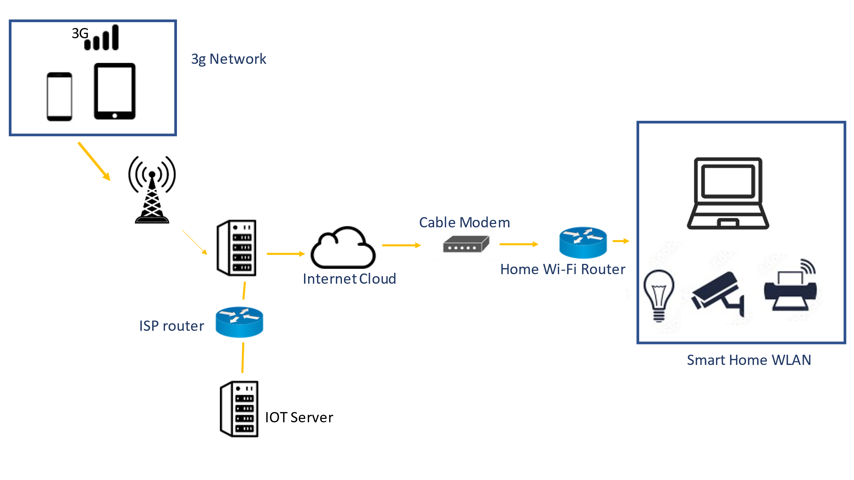

Figure 1.0 Methodology of the Design

Figure 1.0 above depicts the network topology that was used to create the smart house. The smart house, internet cloud, IoT server, and 3G network are the components that make up the implementation.

The First part of the diagram shows devices (smartphone, Tablet) is connected to the cell tower for internet connection to remotely access the devices. The second section focuses on the IoT server, which logs all the devices connected to it to offer further functionality related to the internet of things. Moving further the internet of things devices are connected to the internet cloud (WAN), which is connected to the home Wi-Fi router through a cable modem. Then lastly different Internet of Things devices connected to the home gateway are part of our home network.

## Configuring Devices

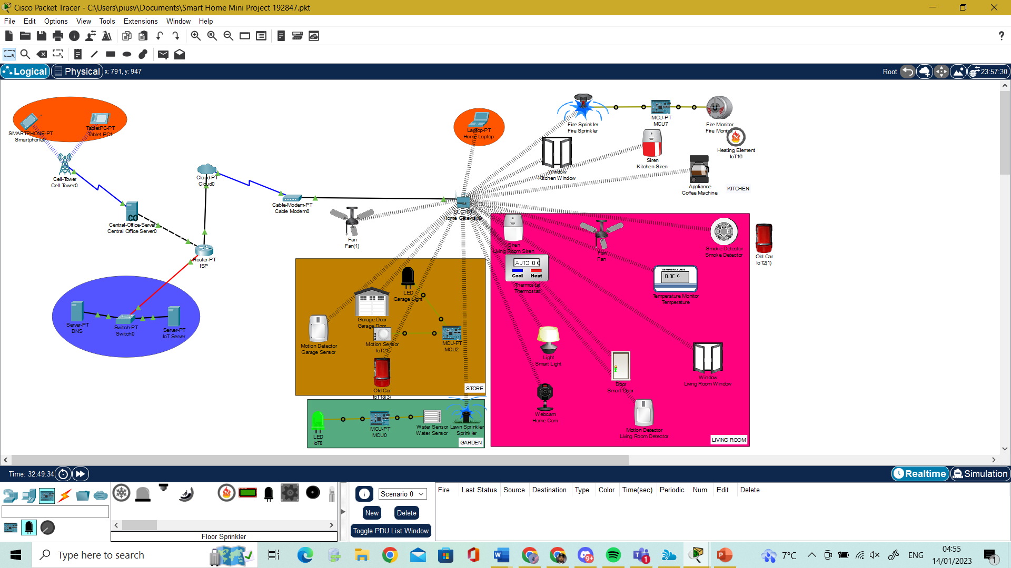

Figure 1.2 Smart Home with Cisco Packet Tracer

Using the methodology outlined on the figure 1.0, the simulation of a smart house with Cisco Packet Tracer is shown in Figure 1.2 above. Home gateway, cloud, ISP (internet service provider) router, central office server, IoT (internet of things) Server, cell tower are the devices I must configure and display below.

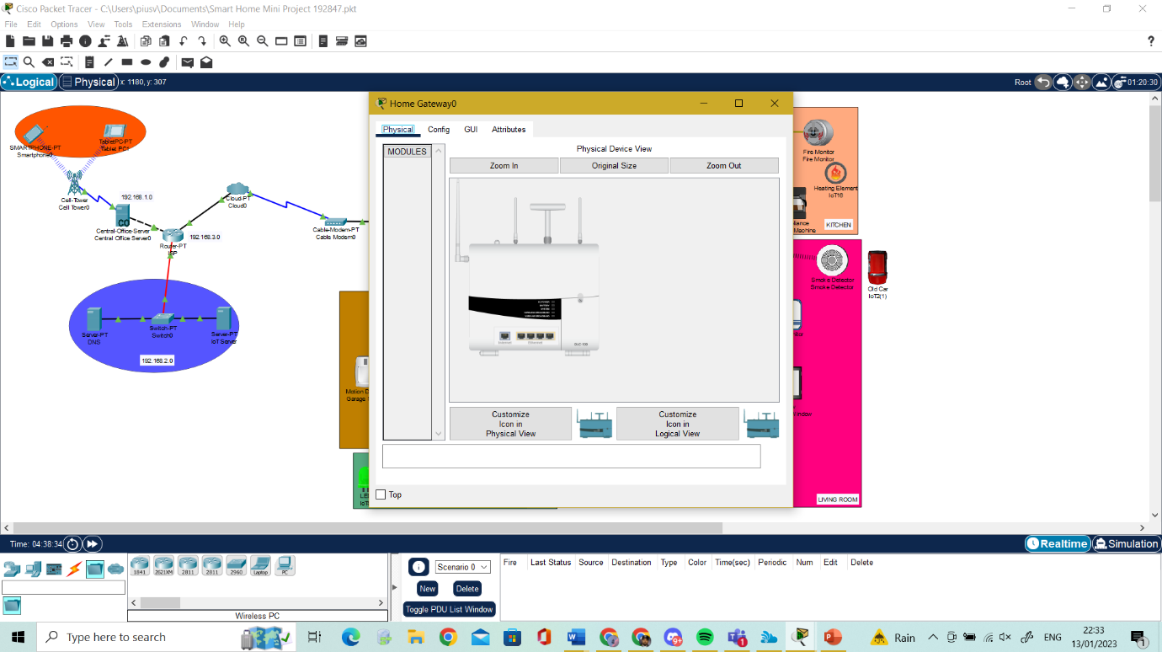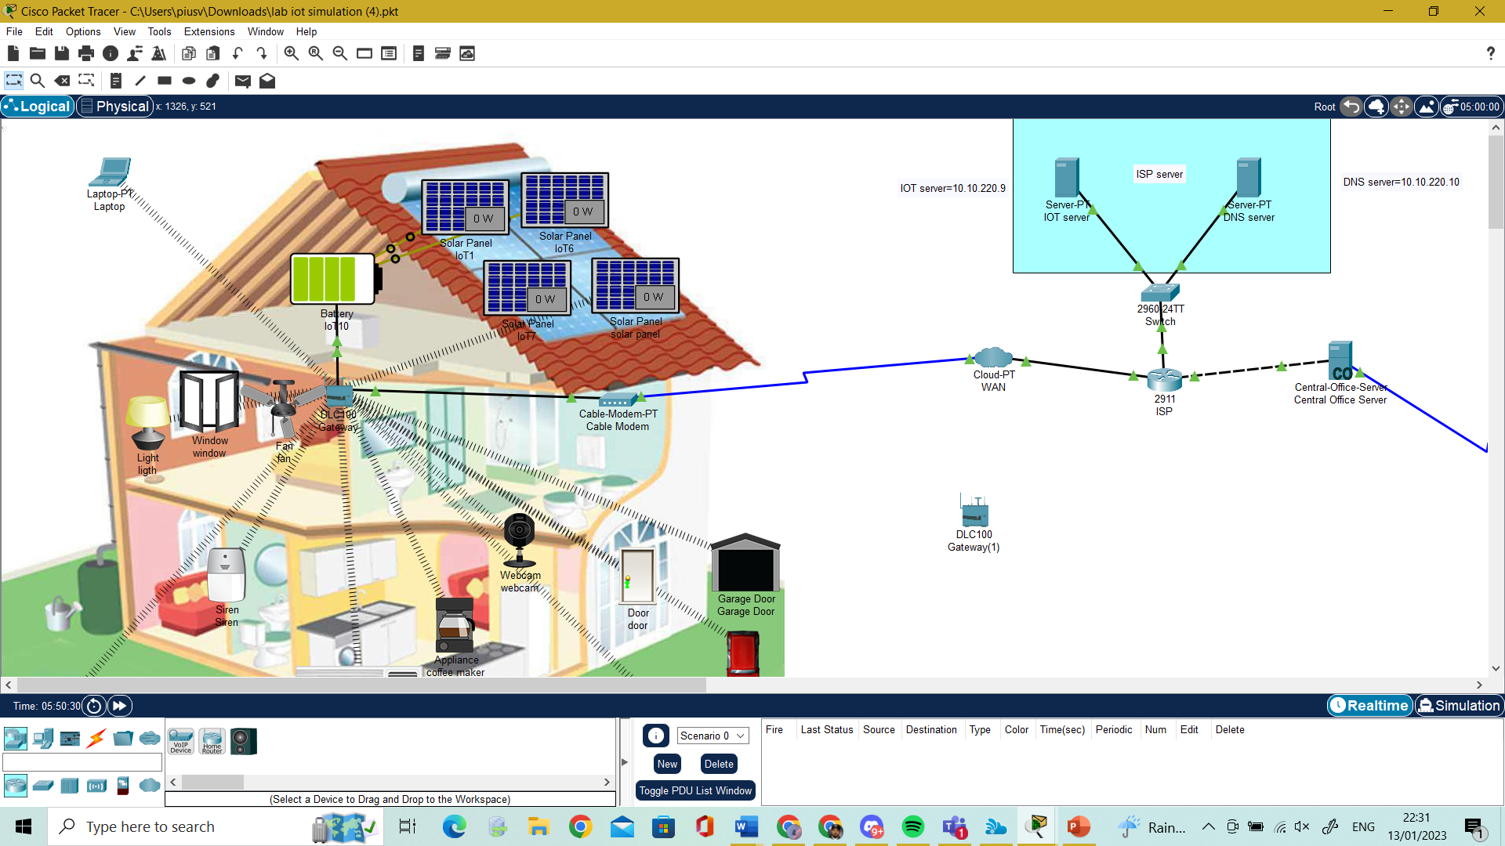Home Gateway **-** used for registering smart devices and providing IP addresses to them. After connecting to the cloud WAN, the home gateway instantly receives an IP address from the ISP Router. Additionally, every smart device connected to the home gateway receives an IP address immediately via the cloud from the ISP router (WAN). The residential gateway is linked to the cloud using a cable modem.

Figure 1.3 Home Gateway

The home gateway has Ethernet connections and a wireless access point with the SSID. Since the devices will be connected through wireless connection, I setup wireless. Since the devices will be connected using wireless connection, I specified the SSID of the home which I named "SMARTIOT" to the gateway in the devices with same Authentication Phrase “SMARTIOT”, this is shown in figure 1.4 below.

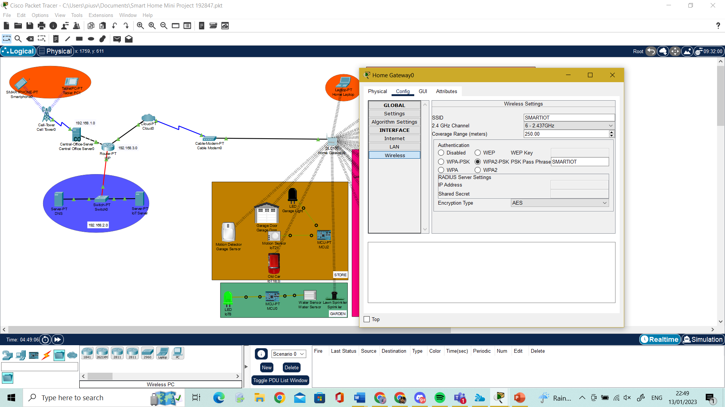

Figure 1.4 Home Gateway Configuration

All smart devices are connected to the home gateway the same way. In Figure 1.5 shows how a device is configured.

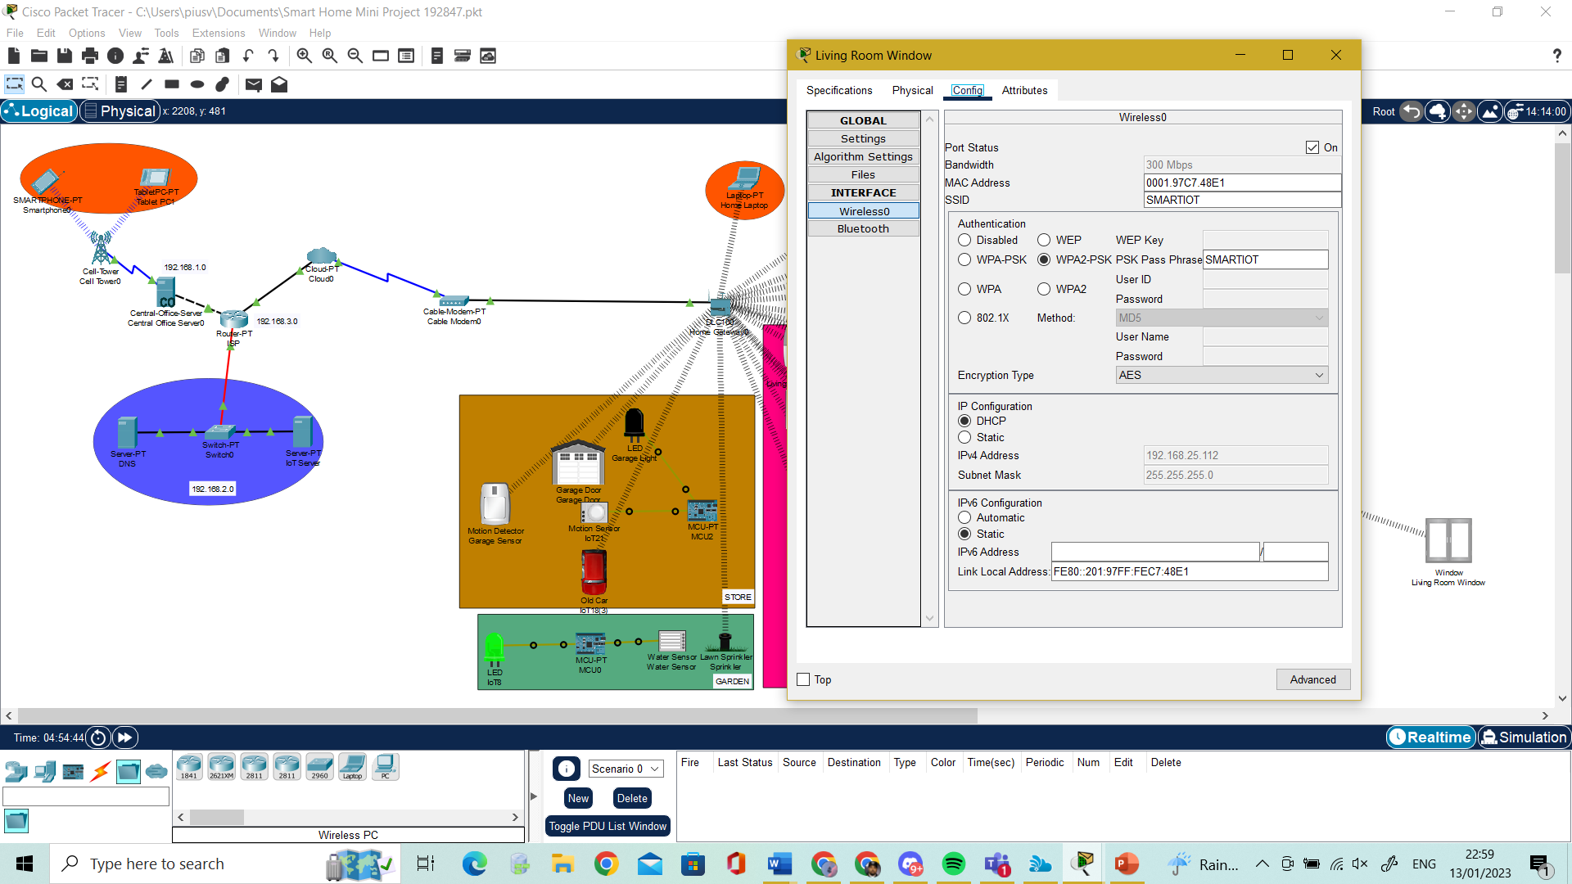

Figure 1.5 Smart Device Configuration

ISP Router **-** To simulate internet access, all the network interfaces are linked to an ISP router (internet service provider) as illustrated in Figure 1.6. On this router, a DHCP server is configured to assign IP addresses to all connected devices dynamically, whether they are smart devices or not. Hostname assignment and IP address setup are included in the configuration.

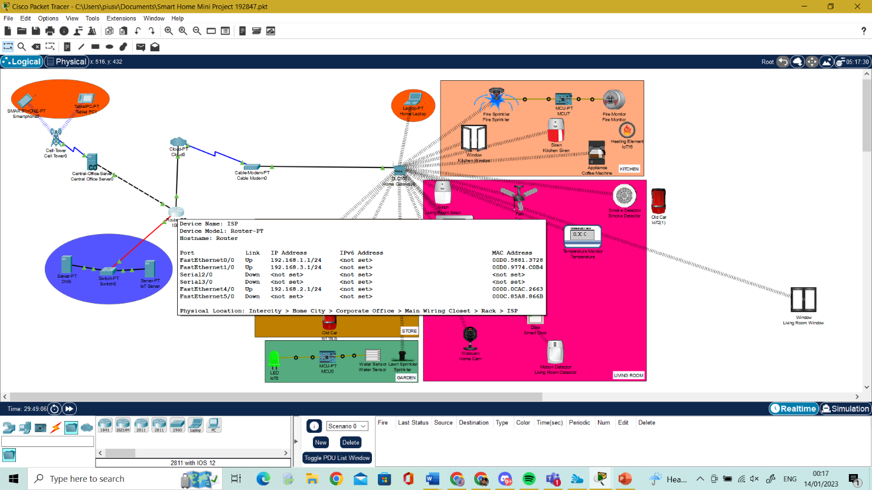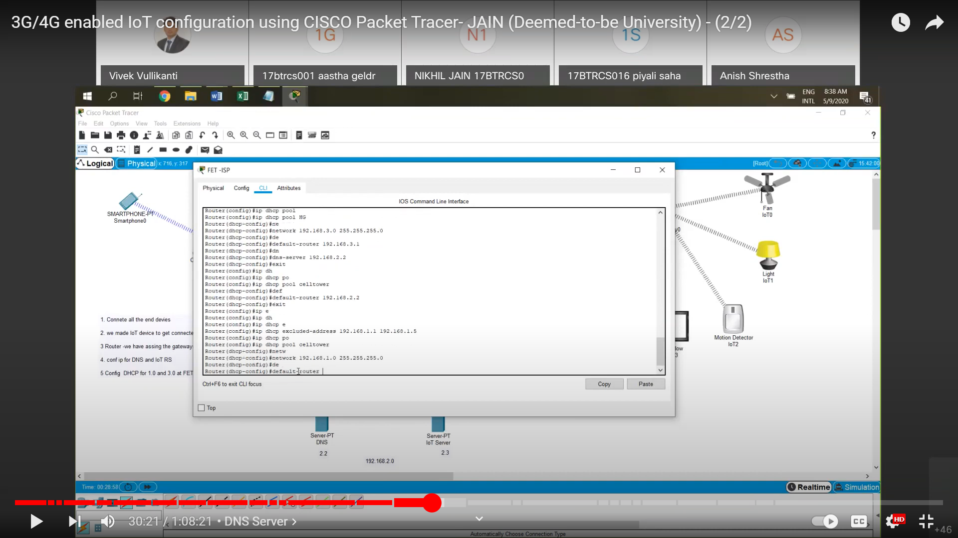

Figure 1.6 ISP Configuration

IOT server: The devices can be accessed using the username and password already created on the IOT server, the same username and password must be supplied along with the IP address of the IOT server when the devices are registered on the IOE server. The device registration on the IOT server is shown in Figure 1.7 and Figure 1.8.

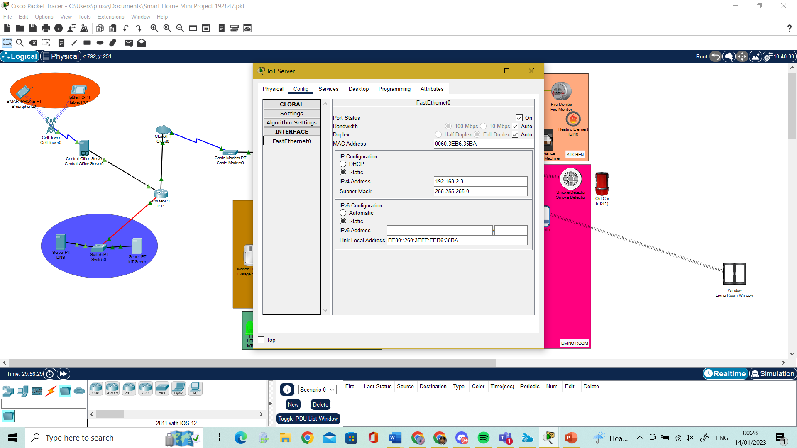

Figure 1.7 IOT Configuration

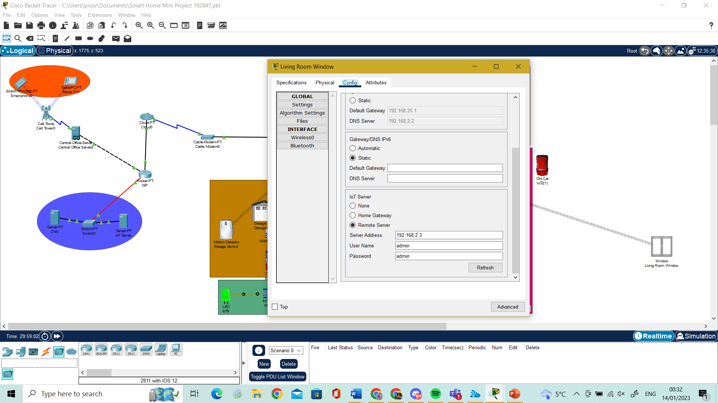

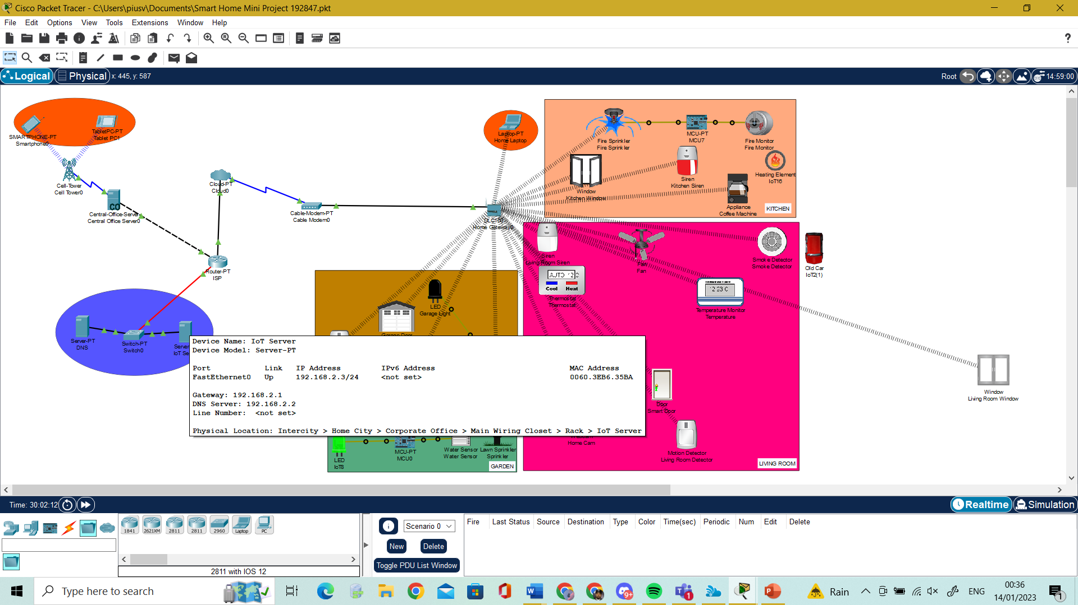

Figure 1.8

DNS server: is used to allow users to remotely contact Internet of Things servers by using my name as a web address “www.pius.com" rather than the IP address. As seen in Figure 1.9, it's crucial to configure the DNS server with a static IP address.

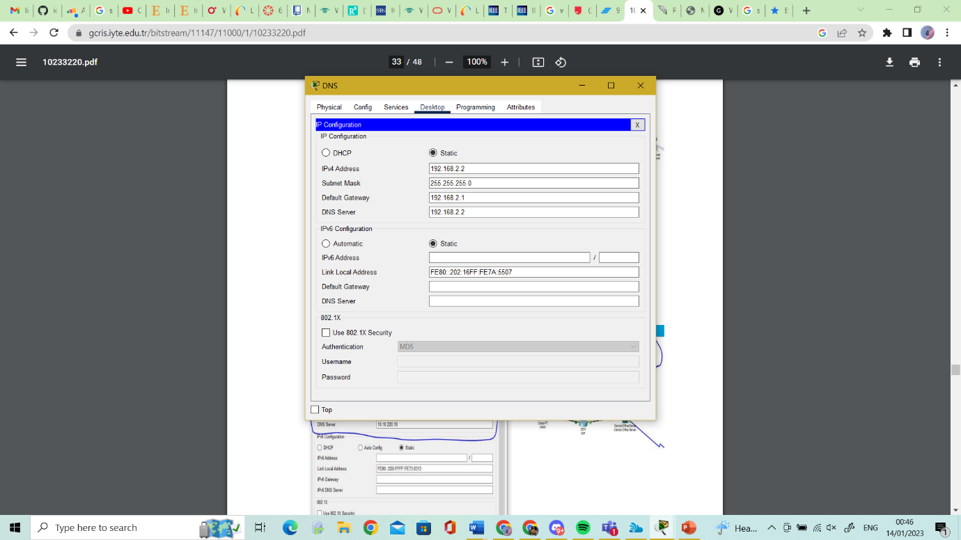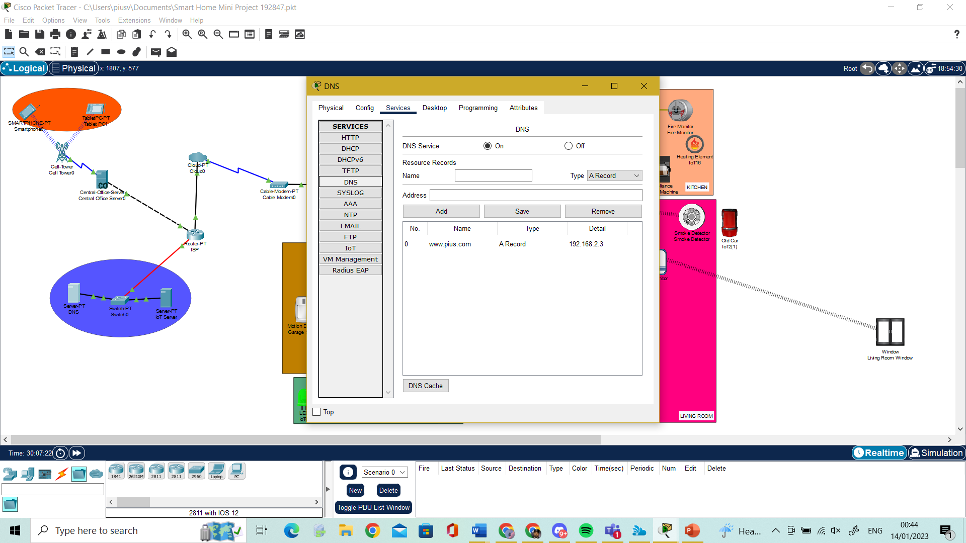

Figure 1.9 DNS Server

IOT Cloud: The smart devices collected data from the home is transferred to the IoT server via IOT cloud (WAN) so that it can be stored. The home gateway sends the IP address to the smart devices via the cloud. Figure in 2.0

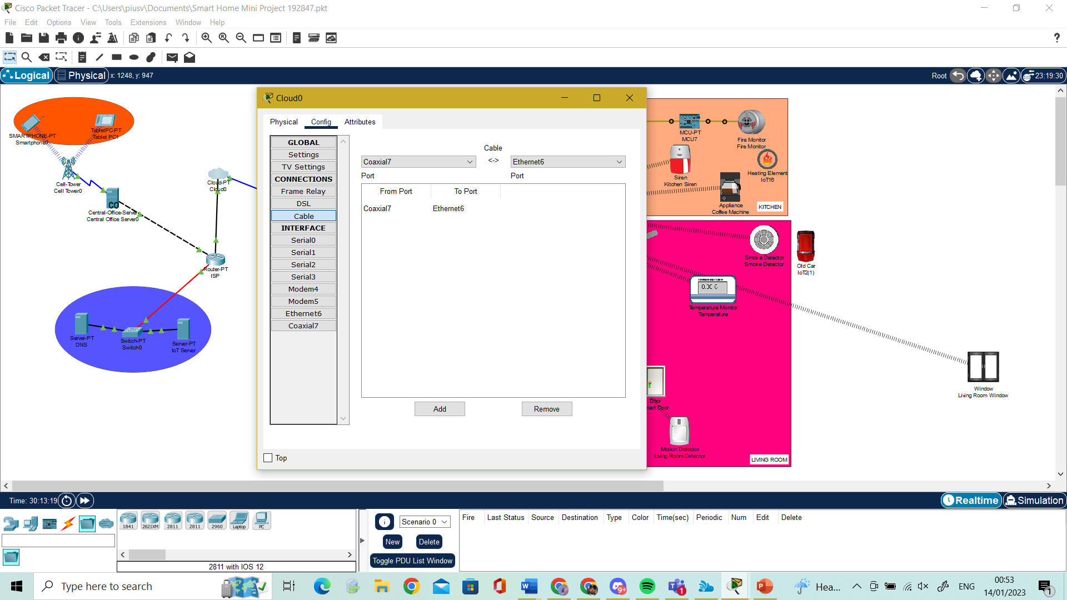

Figure 2.0 IOT Cloud

Central Office Server is used to connect cell tower to ISP router and vice versa for information transferring between them. The central office server automatically obtains all IP information from the ISP after configuring the DHCP server and DNS server on the ISP router, as shown in Figure 2.1.

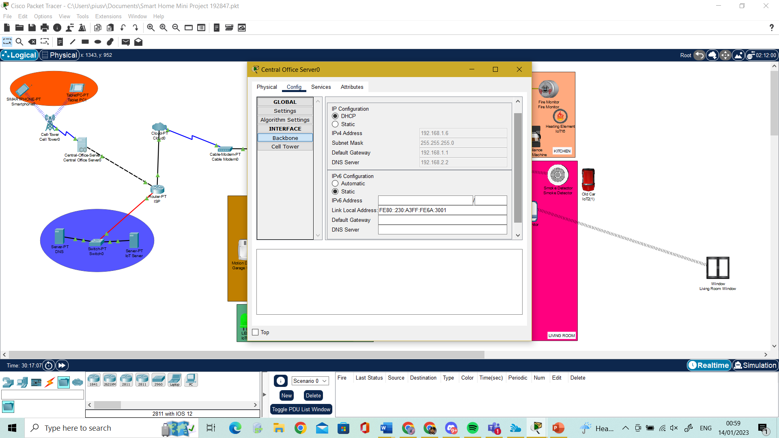

Figure 2.1 Central Office Server

Cell Tower: For the homeowner to access and manage the home appliance from a distance, a cell tower is used to offer cellular system coverage. Figure in 2.2

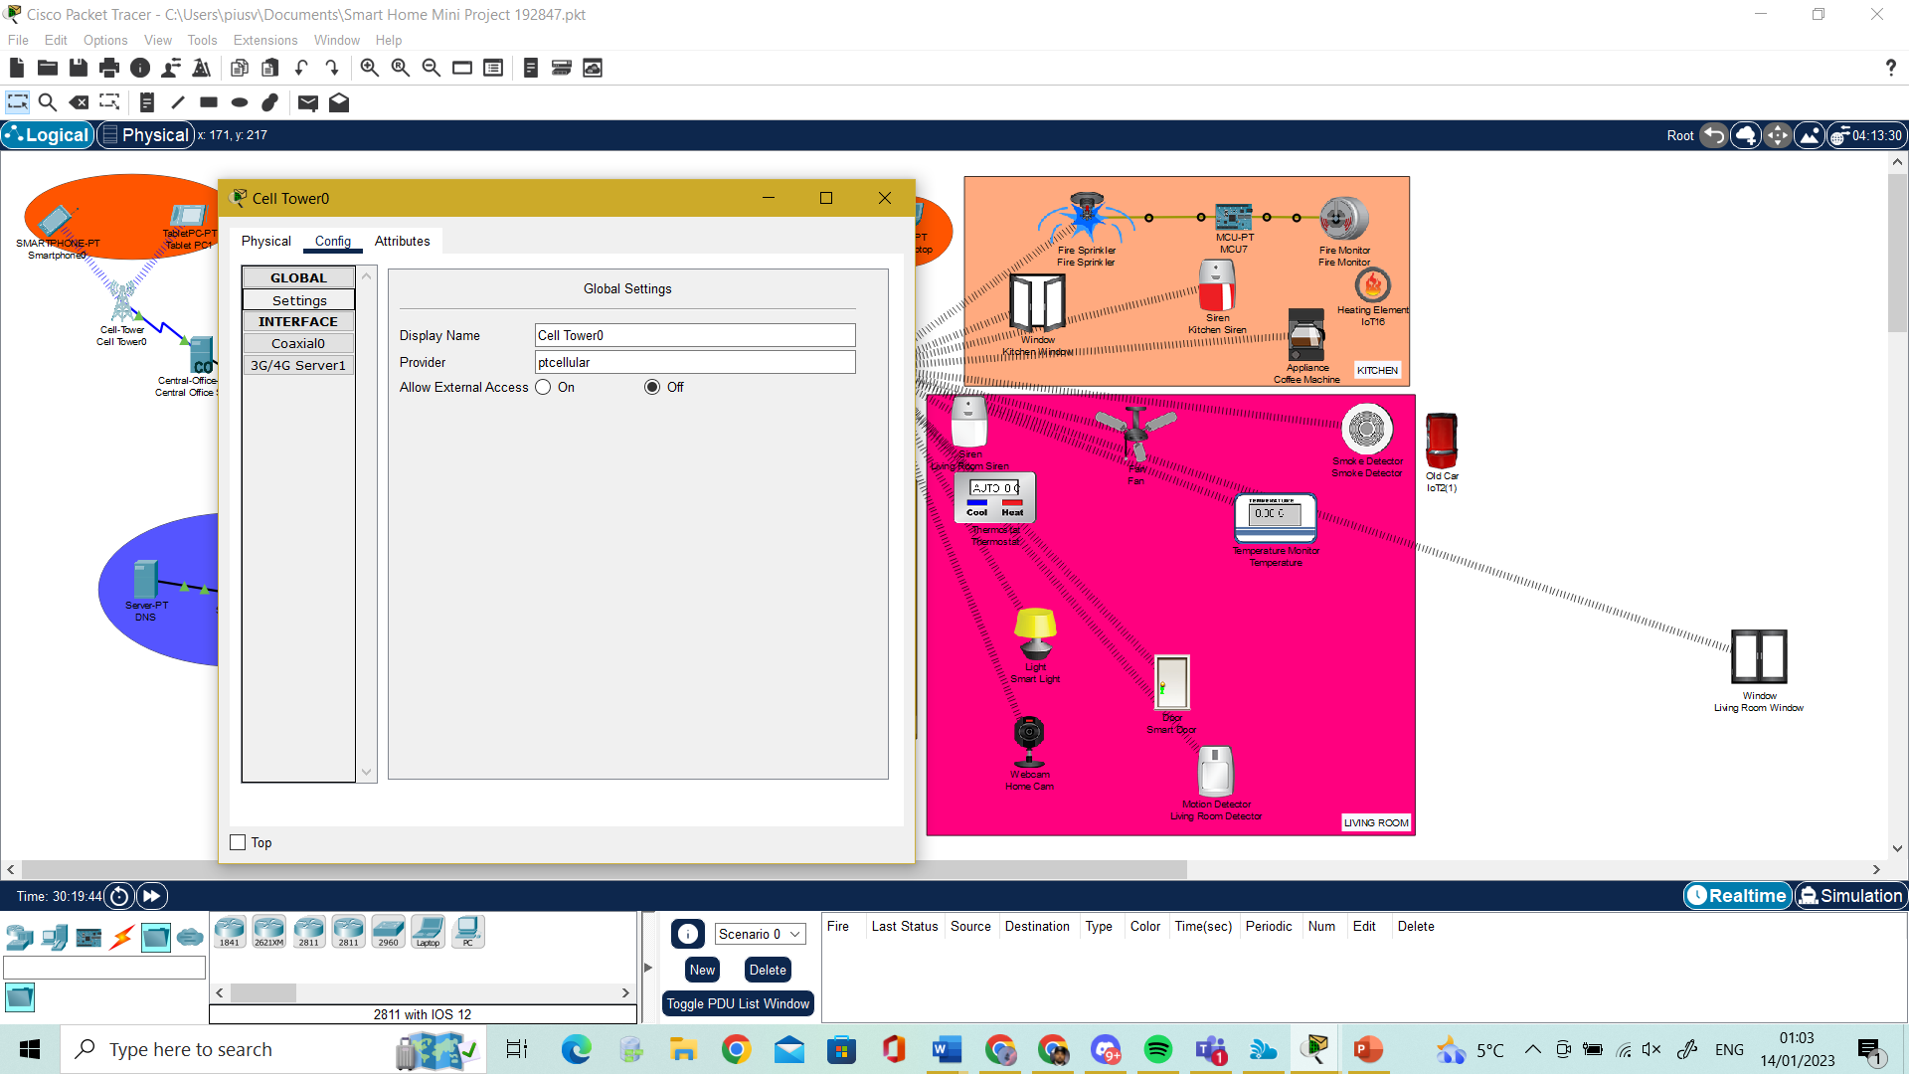

Figure 2.2 Cell Tower

Cable Modem**:** connects your home to the internet. It offers internet access. In the simulation, there is no setting for these specific devices.

Smartphone and Tablet**:** Using a smartphone or Tablet and an internet connection, one can access a smart device remotely via a web interface at “www.pius.com“or using the Ip address “192.168.2.3” to access the internet connection, the cell phone must be connected to a cell tower. This is shown in Figure 2.3 and figure 2.4.

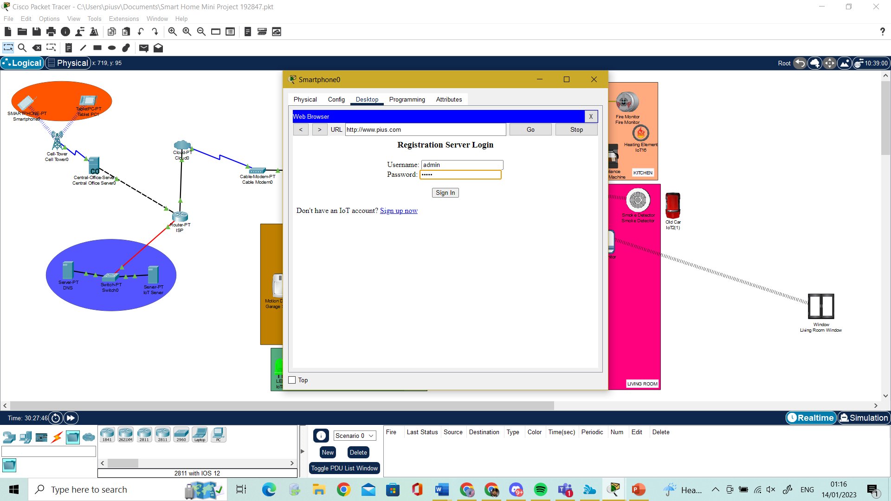

Figure 2.3 Registration Login

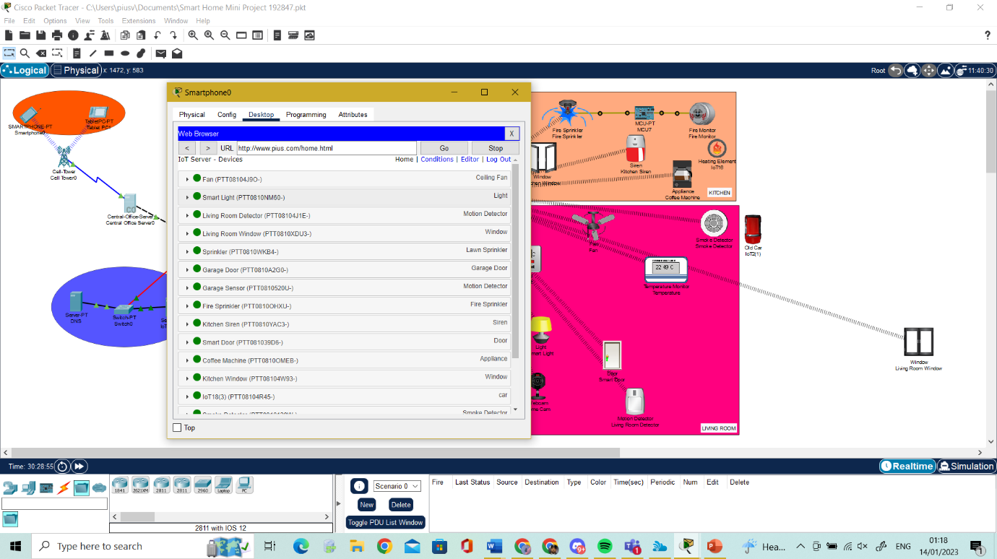

Figure 2.4 Registration Login

## Smart Home Devices

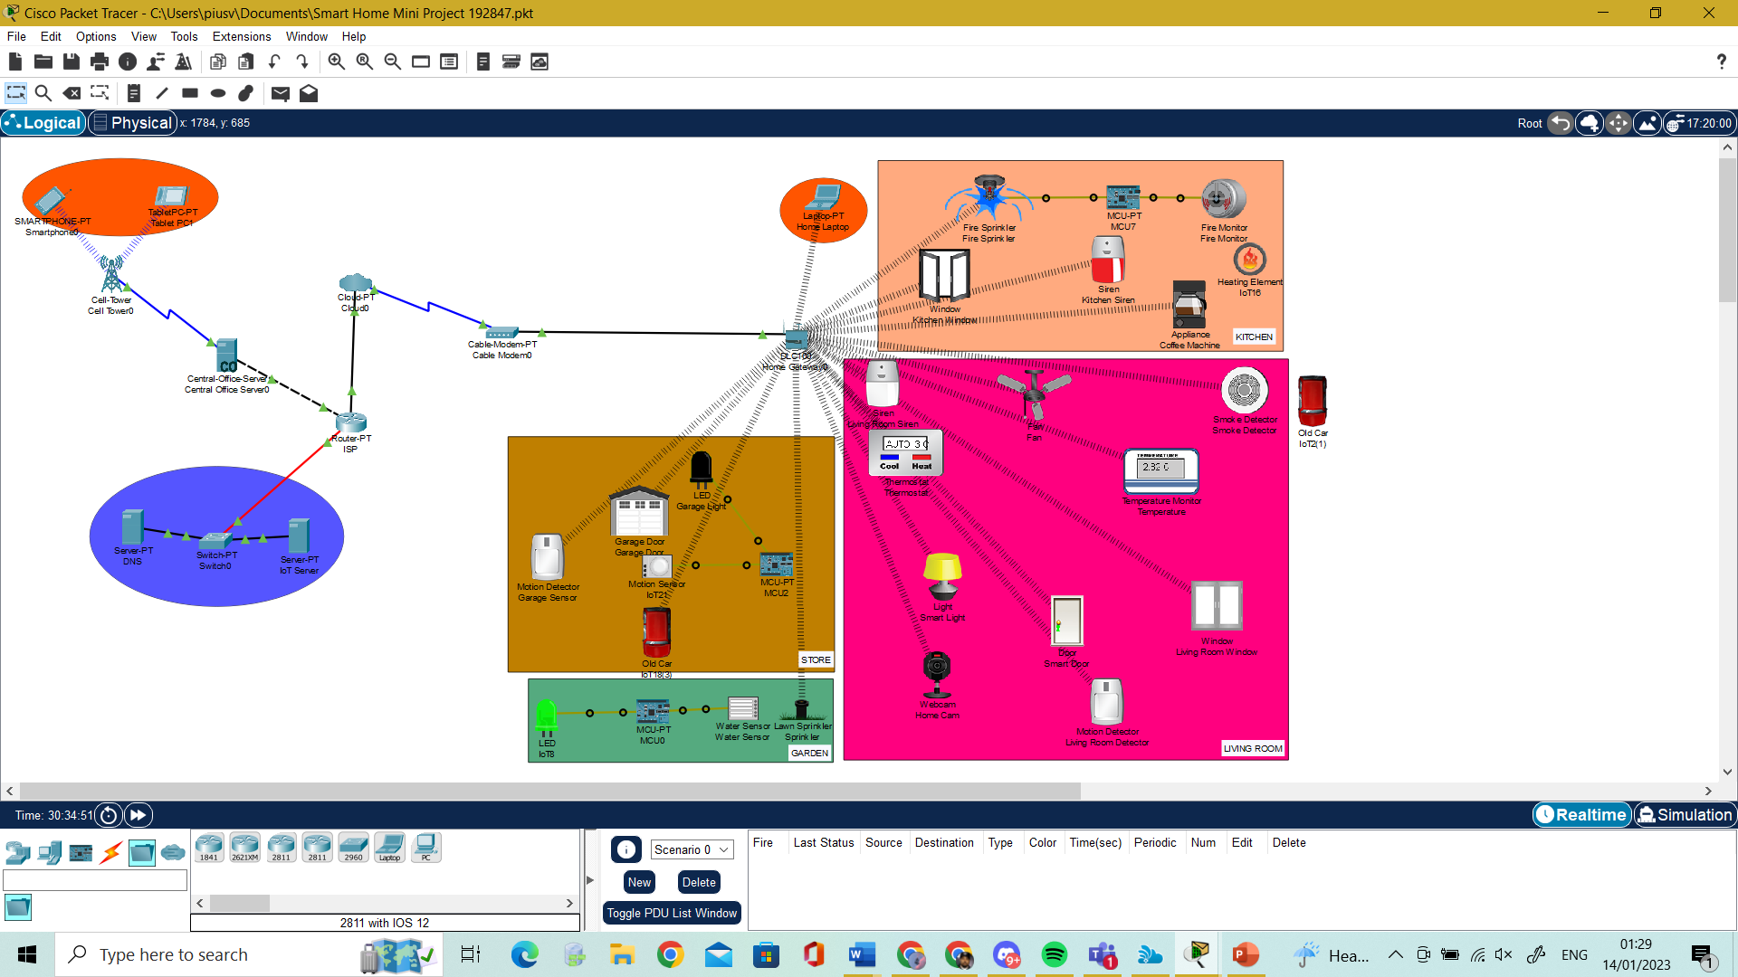

Figure 2.5 Smart Home Devices

In the Smart Home I have designed the devices into separate sections of a house these include Storeroom, Garden, Living Room, and Kitchen.

## Storeroom

The storeroom includes a smart garage door, this opens, and closes based on control, a Motion Detector for detecting motion, a motion sensor which also senses motion on a wider range, a LED light that lights up through an MCU board and a car. The motion detector and garage door are connected to the gateway, the conditions for this are that when the motion detector detects motion the garage door automatically opens, this is proposed so that when someone is approaching the garage the garage door will open for the person with ease in diagram 2.7 shows how the condition is configured in IOT monitor in cisco. For the other devices a motion sensor is connected with an MCU board and a LED light, this is designed to let the LED light up whenever motion is detected, in a smart home setting the LED serves as a garage light and will light up whenever someone approaches this is why an old card is being used as a movement tool. In diagram 2.8 shows how the MCU board is programmed for it to work

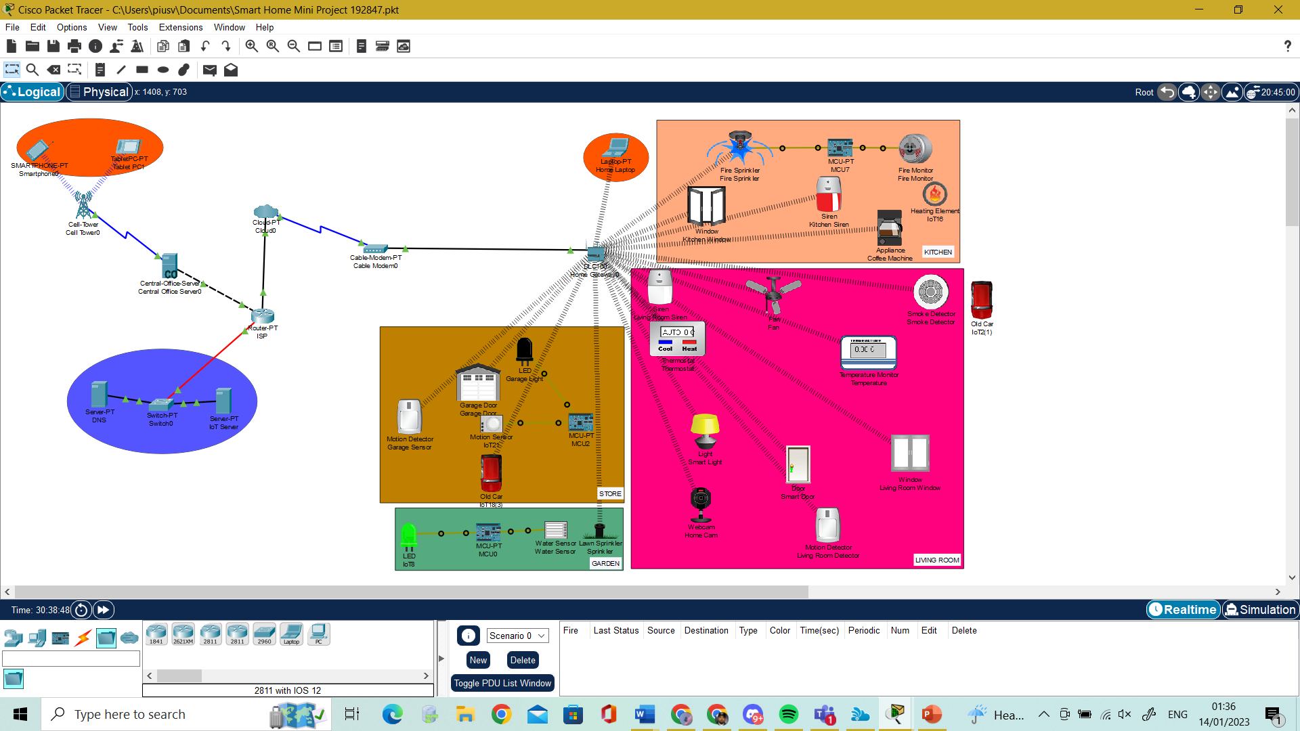

Figure 2.6 Storeroom

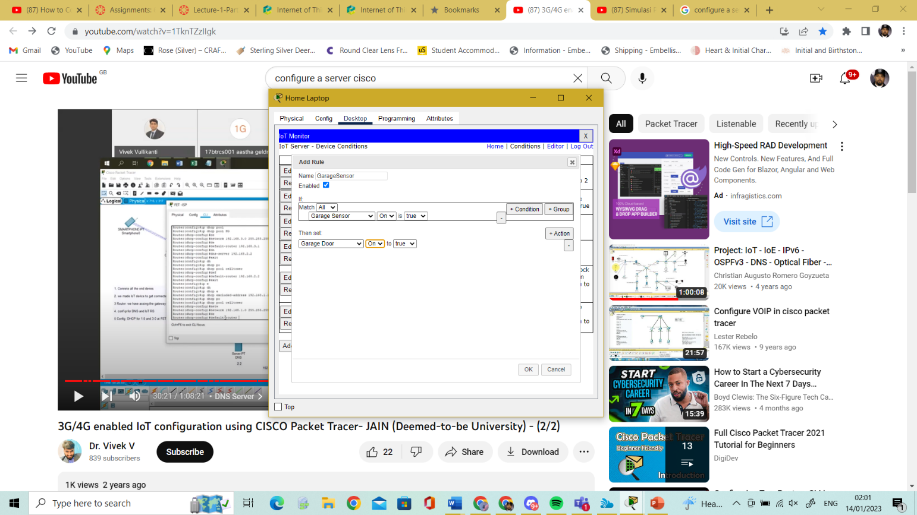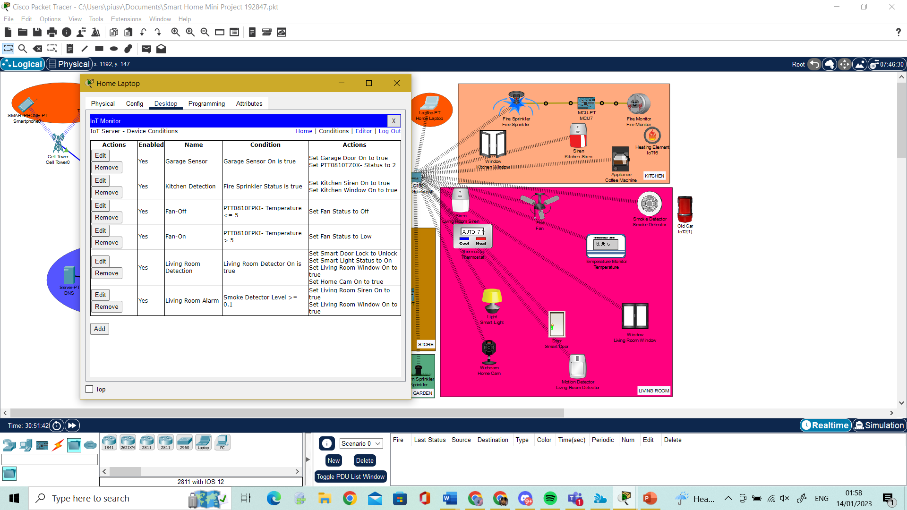

Figure 2.7 conditions for Devices

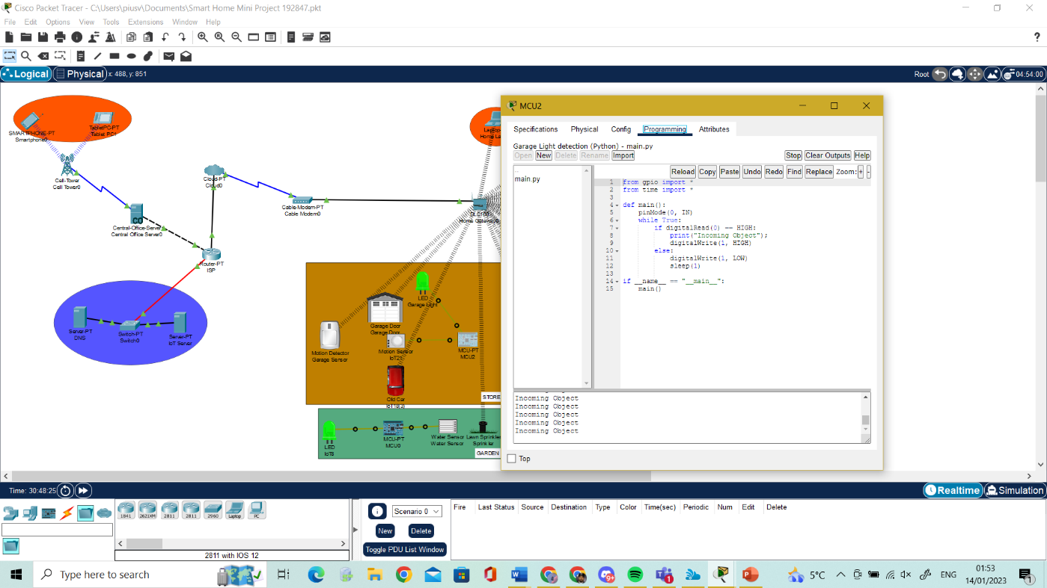

Figure 2.8 MCU Board Python Programming and When Motion is Detected

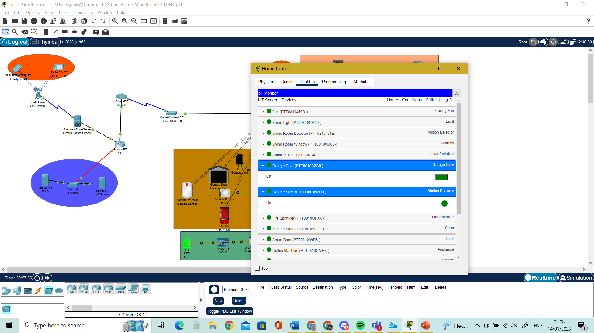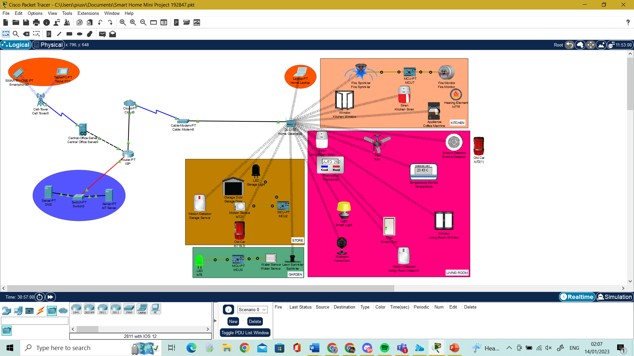

Figure 2.9 Garage Door Opening After Motion Detected

## Garden:

The garden in the smart house includes A smart sprinkler that sprinkles water whenever switched on, and a water sensor that switches on whenever the sprinklers are turned on. A water sensor is connected to a MCU board unto an LED light. In a smart home setting when sprinklers are turned on the water sensor switching the light on will indicate the user if that the sprinklers are still on and can be turned on and off from a smart device. Diagram 3.0 shows the programming of the MCU board to switch the LED on and diagram 3.1 showing sprinkler monitoring on Laptop.

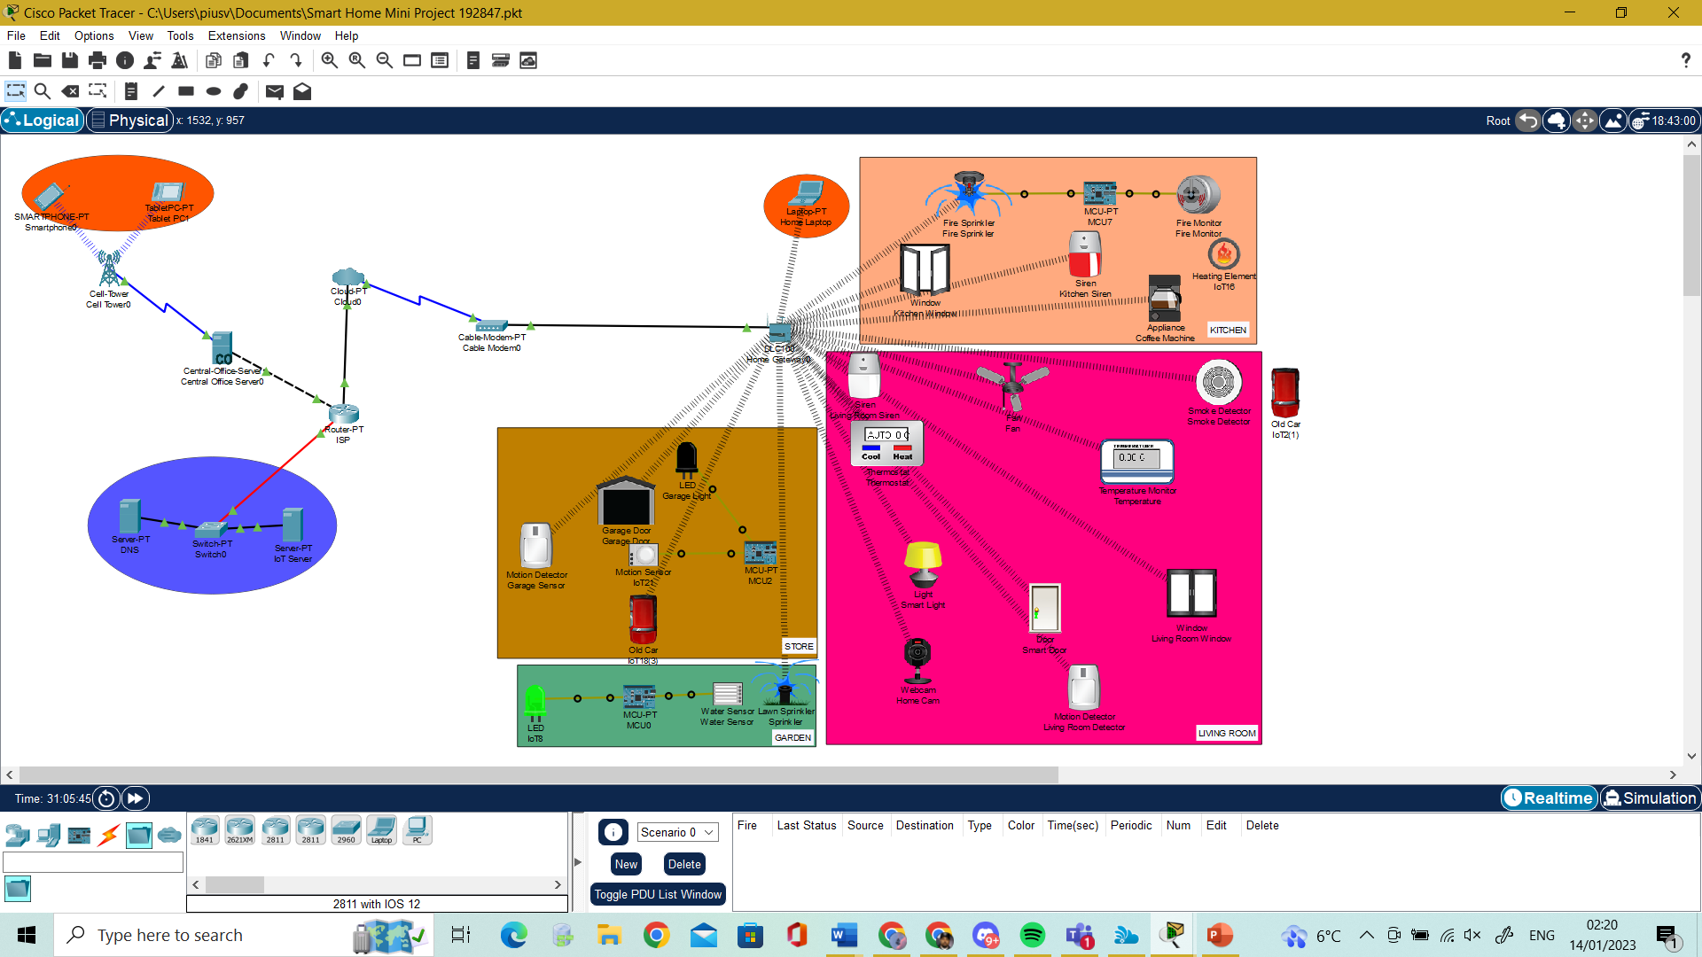

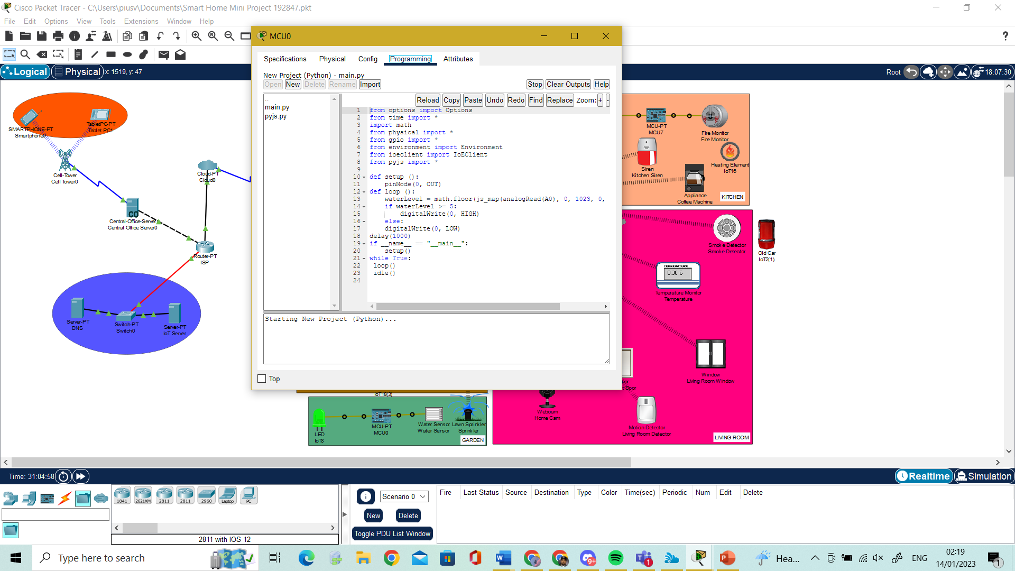

Figure 3.0 Garage Door Opening After Motion Detected

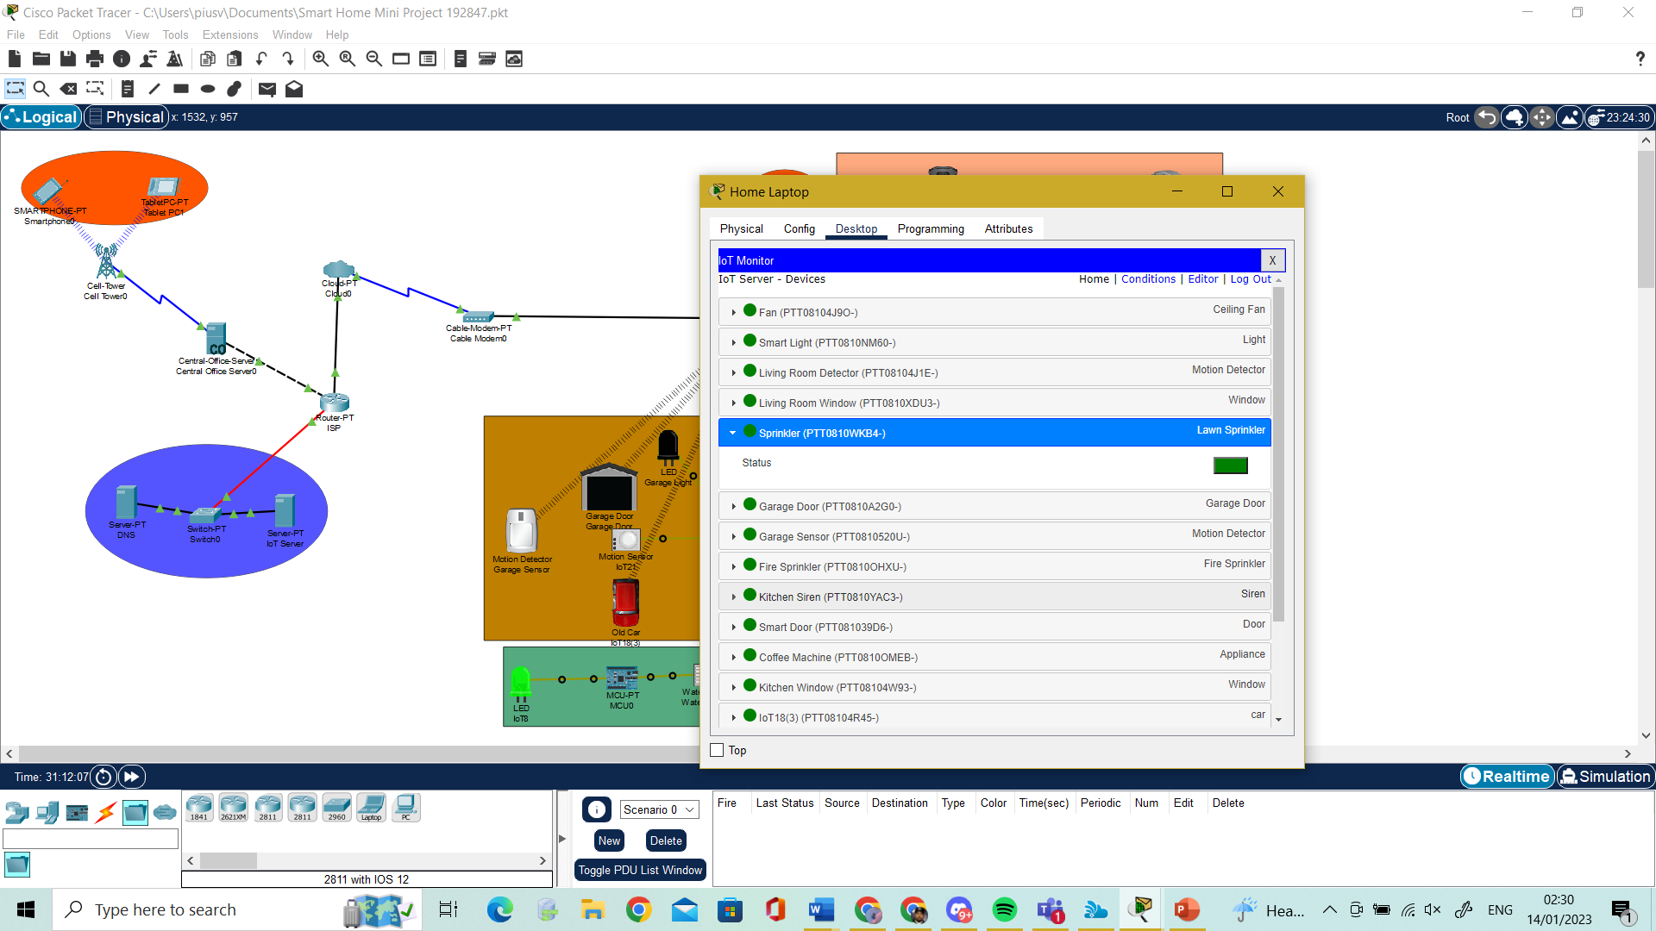

Figure 3.1 Sprinkler Monitoring on Laptop

## Living Room:

The Living Room in the smart house includes a Siren, A Fan, Smoke Detector, Thermostat, Temperature Monitor, Light, Door, Window, Webcam and Motion Detector. In this scenario when motion detector detects movement the webcam switches on, the window opens, the light switches on and the door unlocks all simultaneously. This allows user to feel at ease whenever they return home inside their living rooms without getting up to use set these devices, the webcam also switches on for security purposes. Diagram 3.2 shows how the conditions are put into place whiles Diagram 3.3 shows how it works when motion detector triggers the other devices to work.

For the other devices serve as temperature monitoring in the smart house, when temperature goes above 0.1 degrees Celsius in the house the fan automatically turns on to cool the room if not turns off. Diagram 3.4 shows the condition on how this works and 3.5 shows it working in cisco.

The smoke detector in the living room alerts a siren to go on if smoke is detected inside the room this is shown in Diagram 3.6 and Diagram 3.7. shows the condition for this to work.

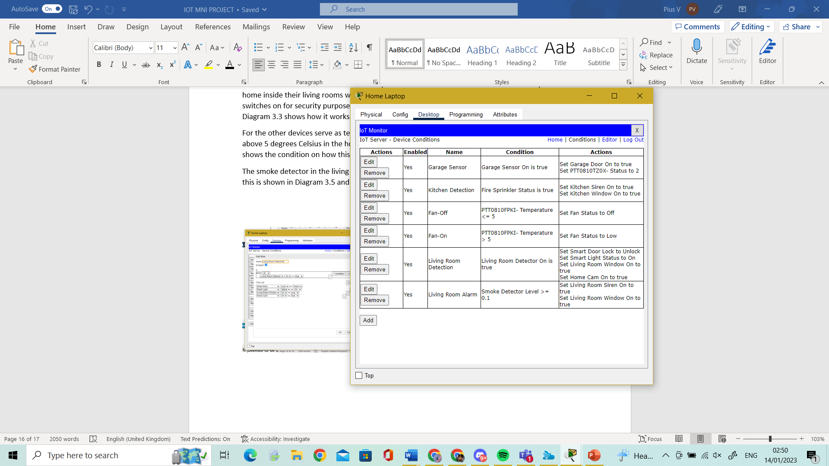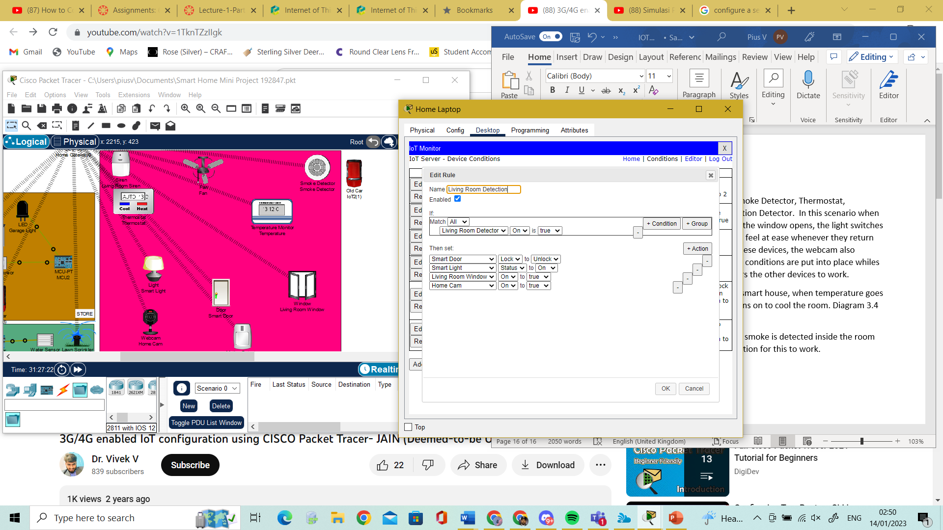

Figure 3.2 Condition for Living Room Motion Detection and Devices

DETECTION

NO DETECTION

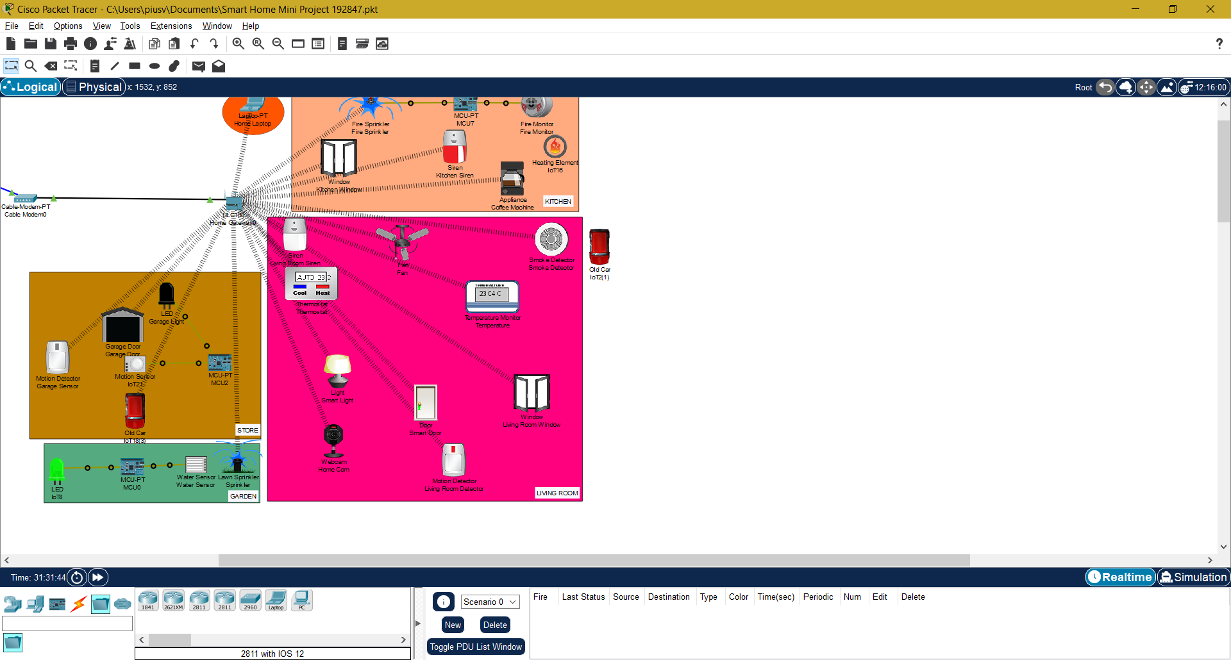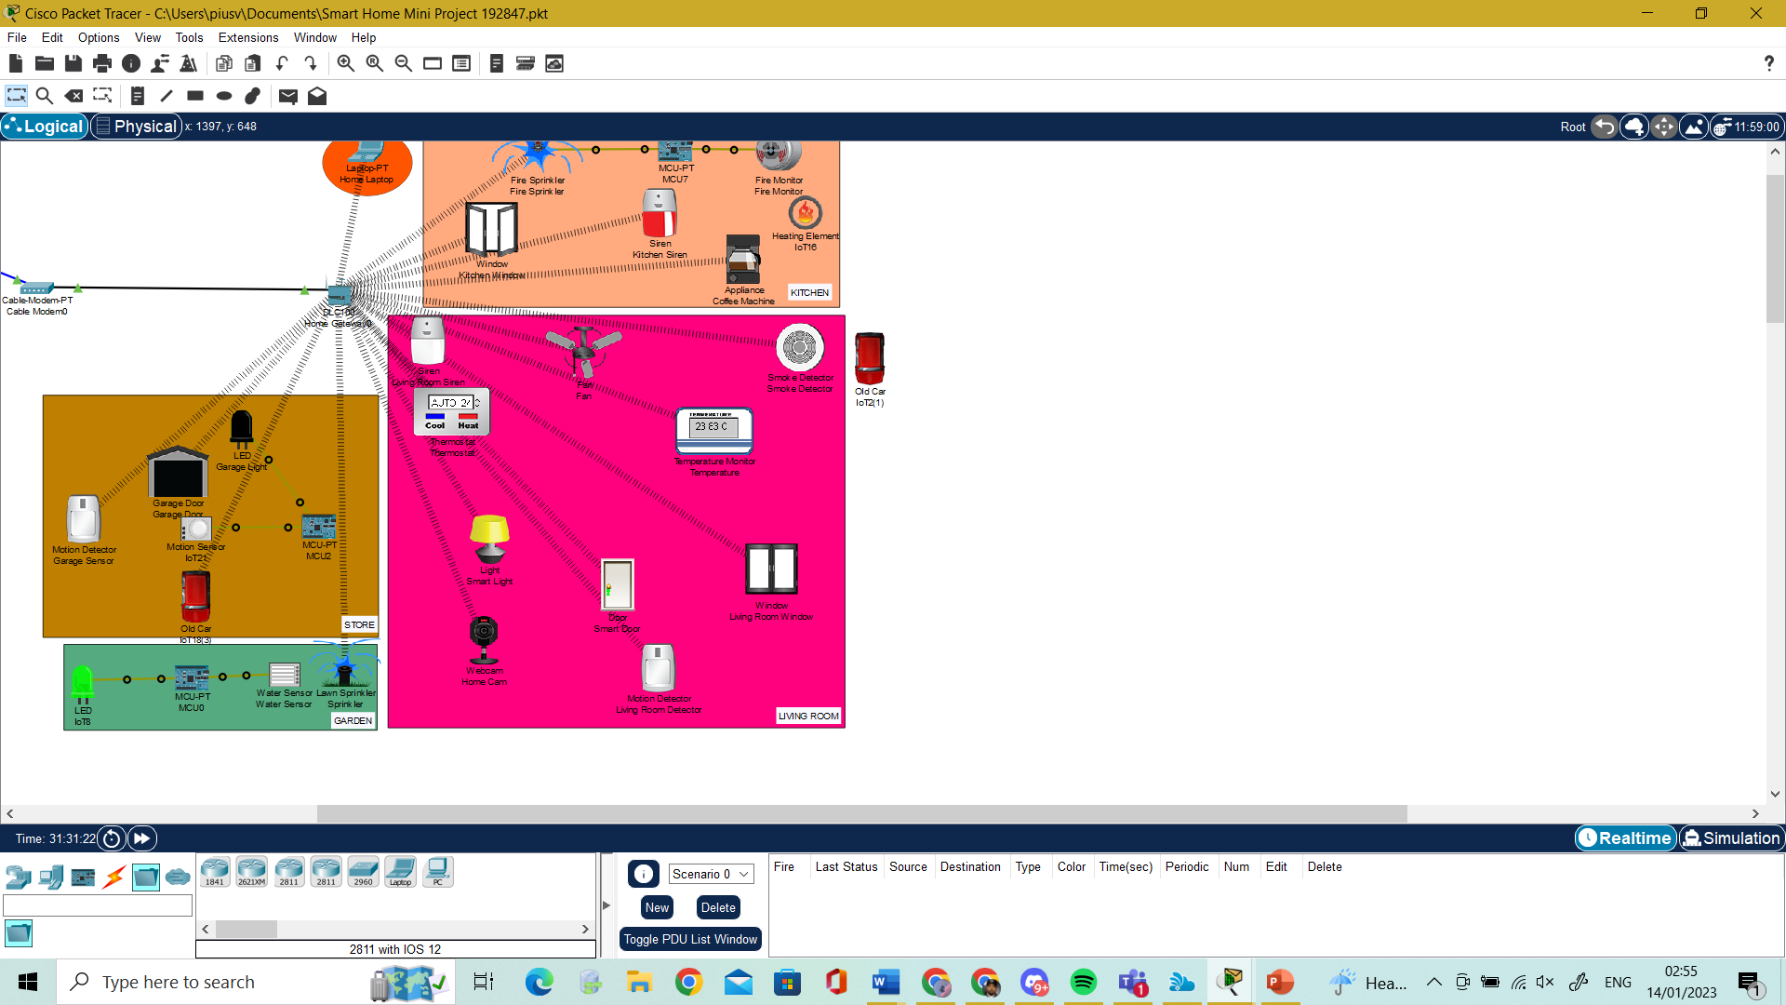

Figure 3.3 Living Room Motion Detection and Devices

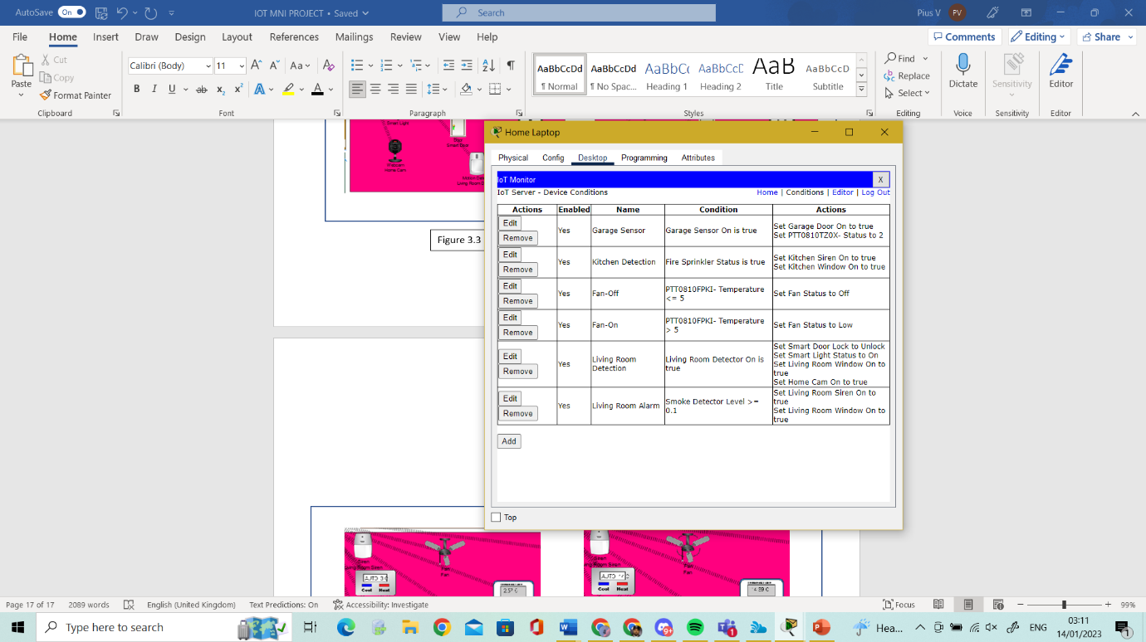

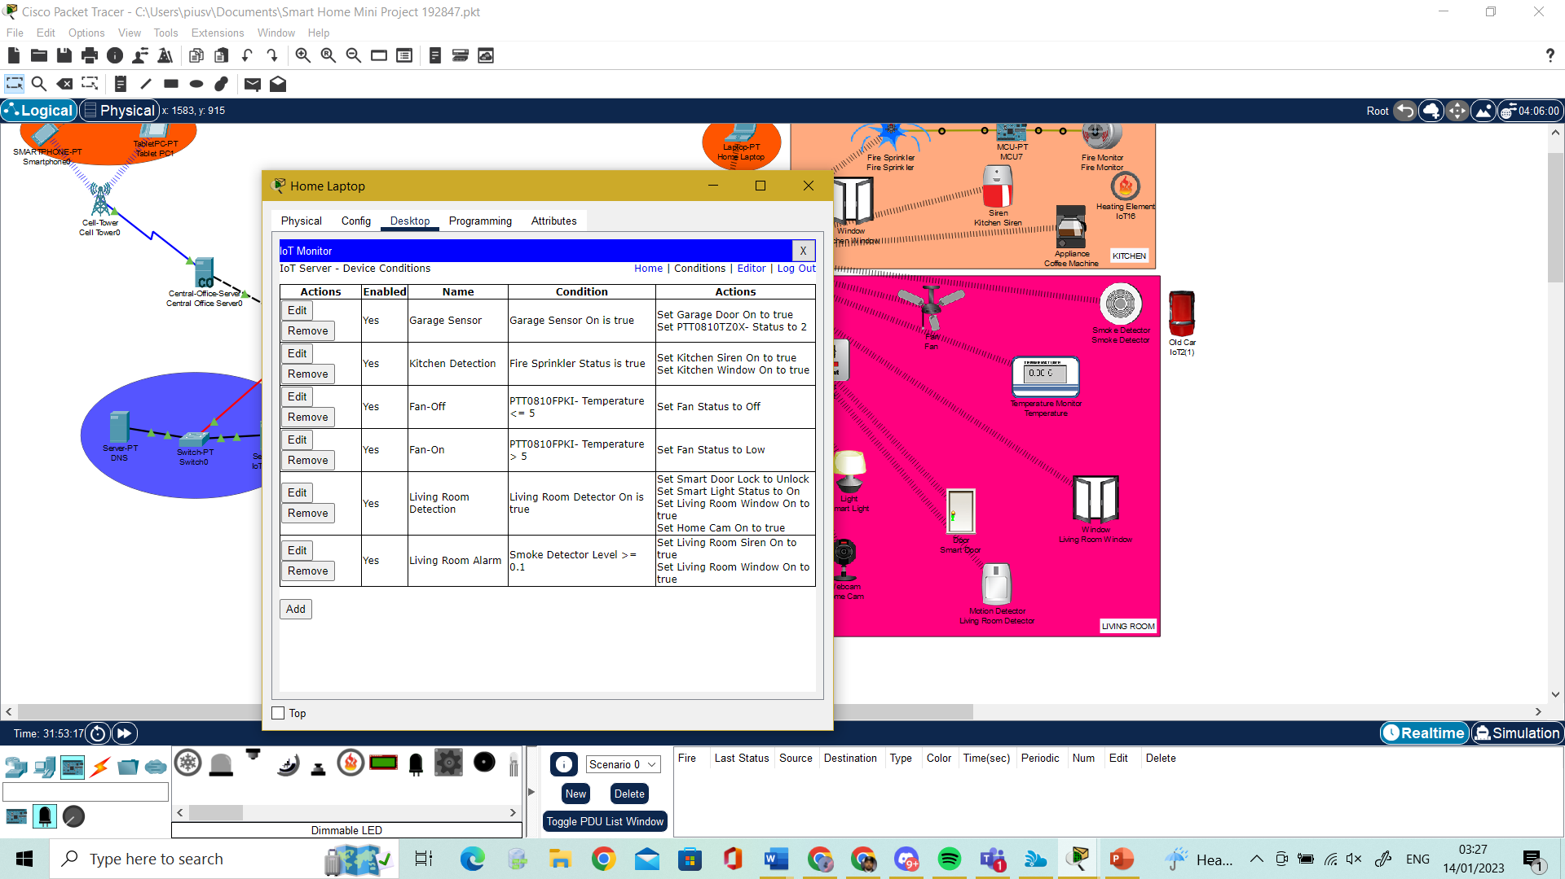

Figure 3.4 Condition for Fan

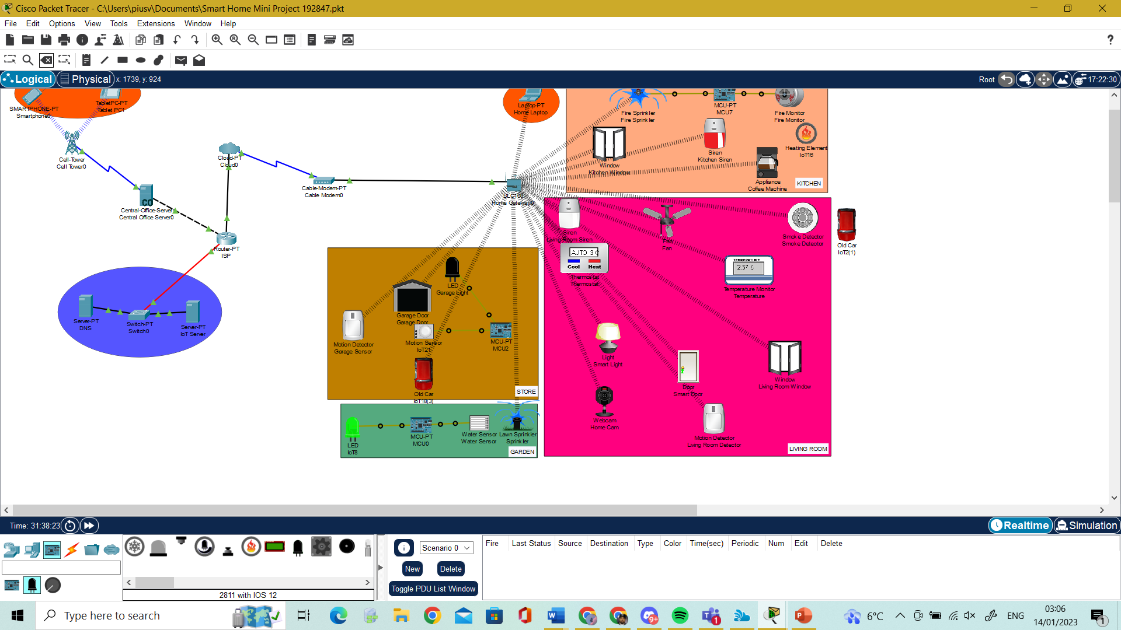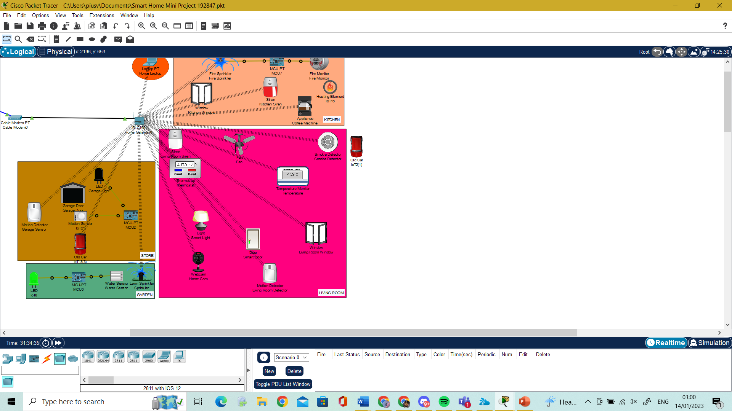

Figure 3.5 Fan Working from Temperature Sensor

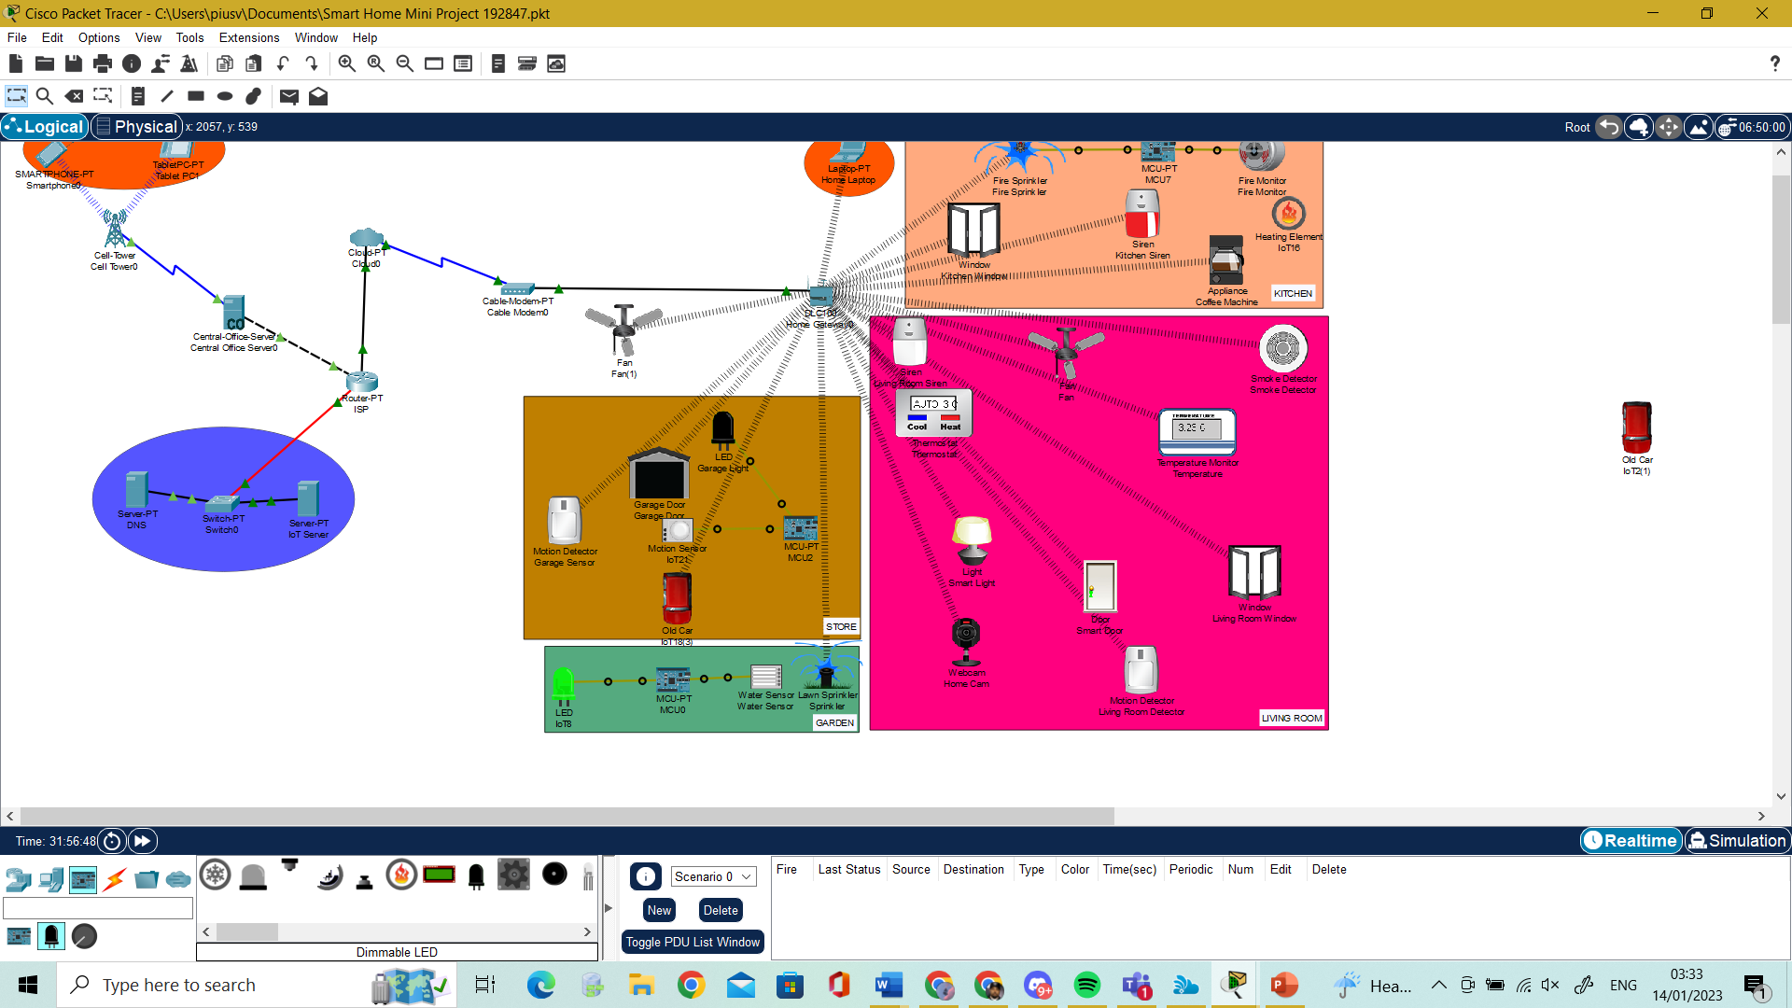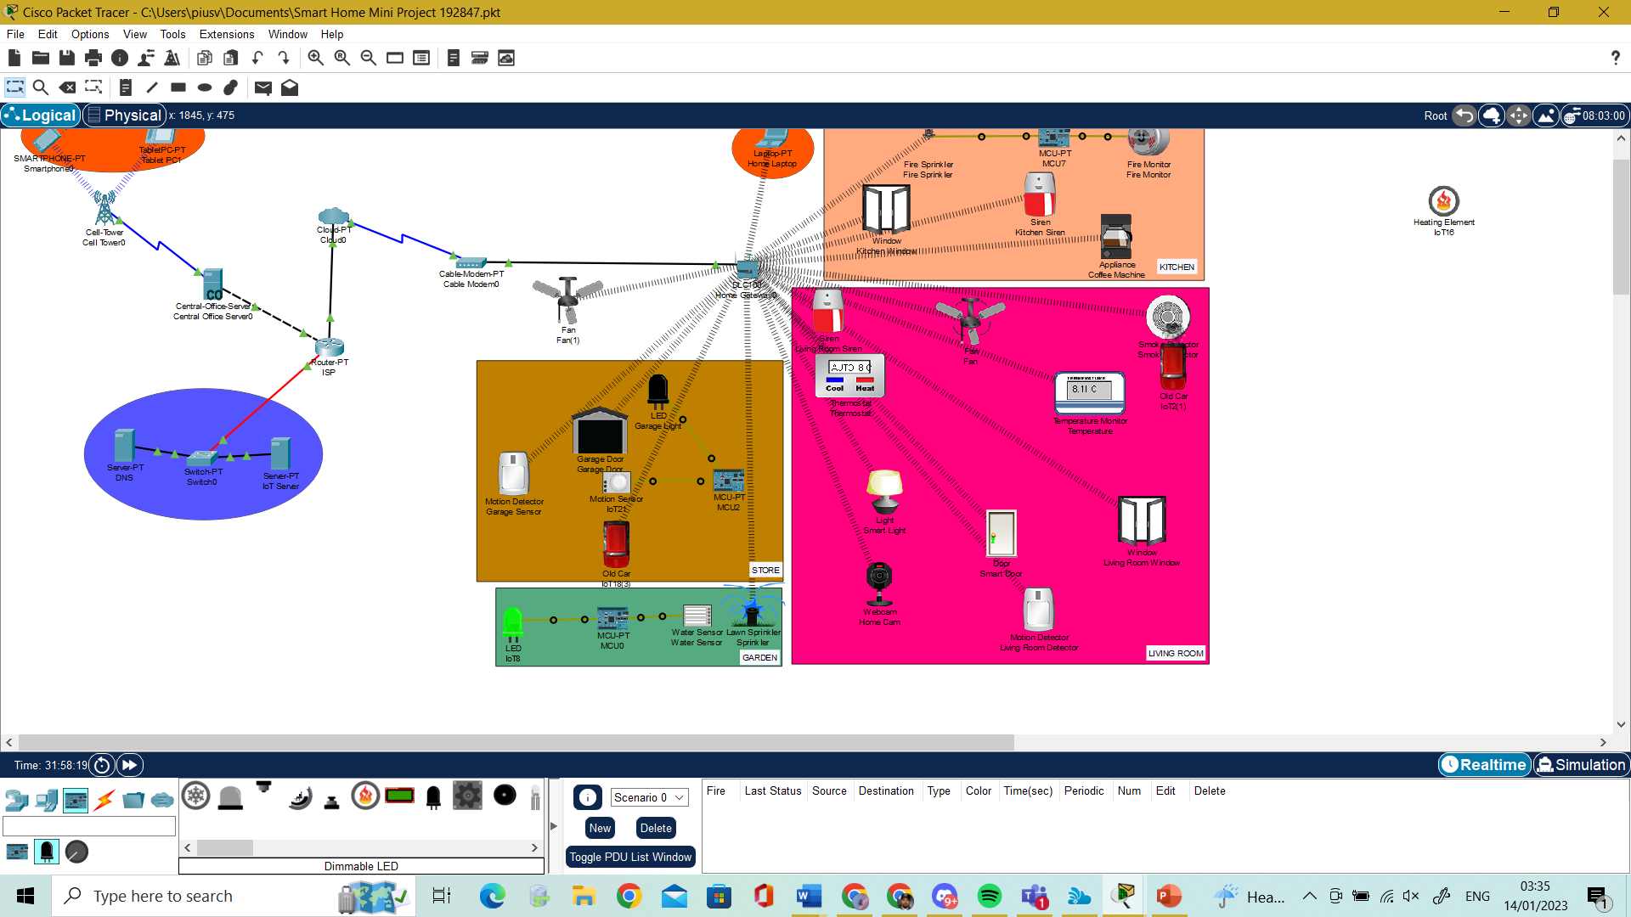

Figure 3.6 Siren Working from Smoke Detection

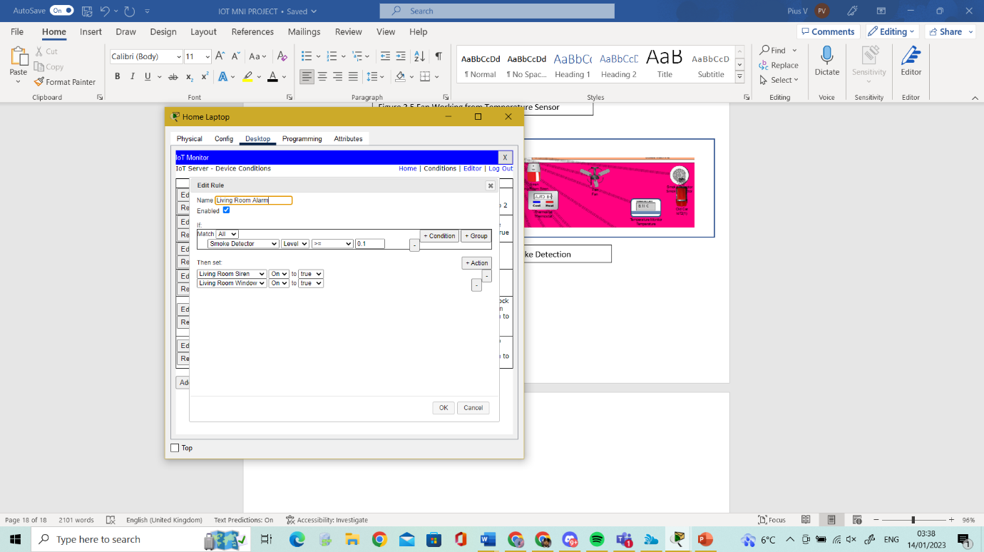

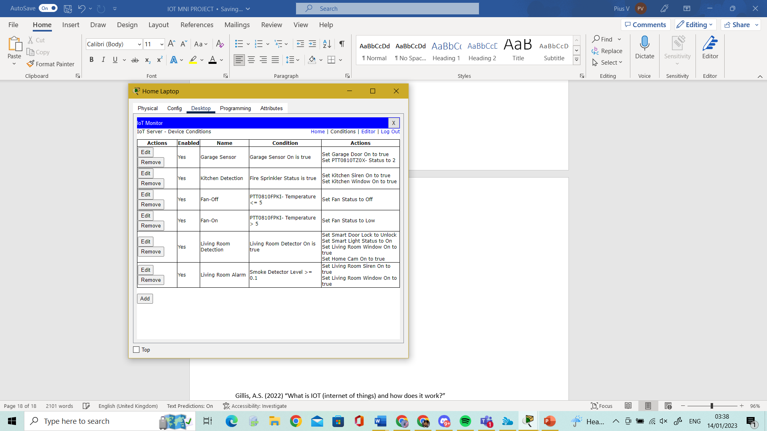

Figure 3.7 Smoke Detection Configuration

## Kitchen

Devices in the kitchen includes window, siren, Coffee Machine Fire Monitor and Sprinkler. The purpose of these devices is to make the kitchen safe in case of a fire the fire sprinkler will turn on, the kitchen window will open, and siren will turn own after said and done the devices can be switched off from a smart device. In diagram 3.8 shows how Fire monitor is connected with an MCU board and Sprinkler to activate sprinkler when Fire Monitor detects Fire. When the sprinklers are on the window and siren are configured to turn on this this can be seen in diagram 3.9, in diagram 4.0 shows a fire component triggering the smart devices to work.

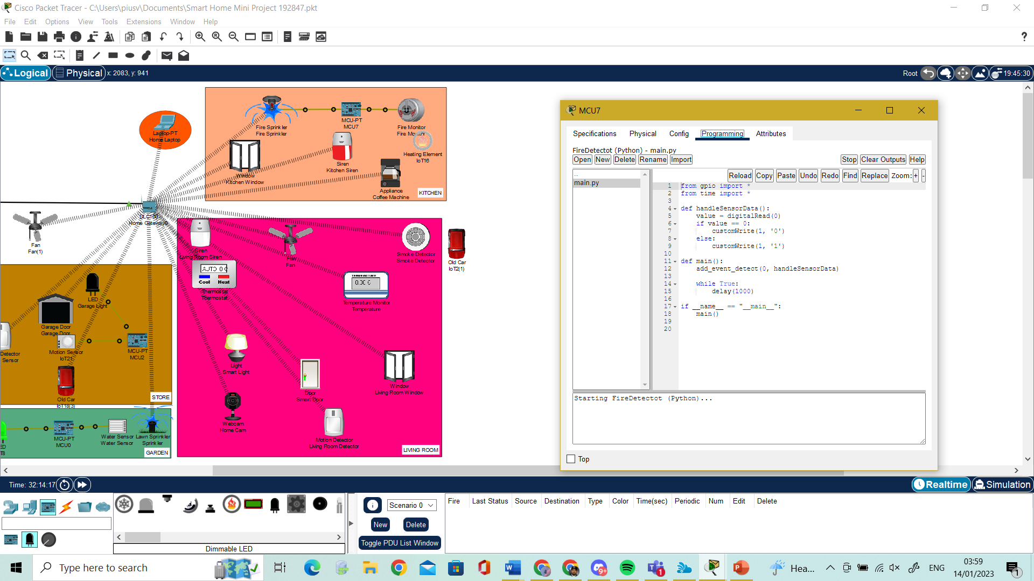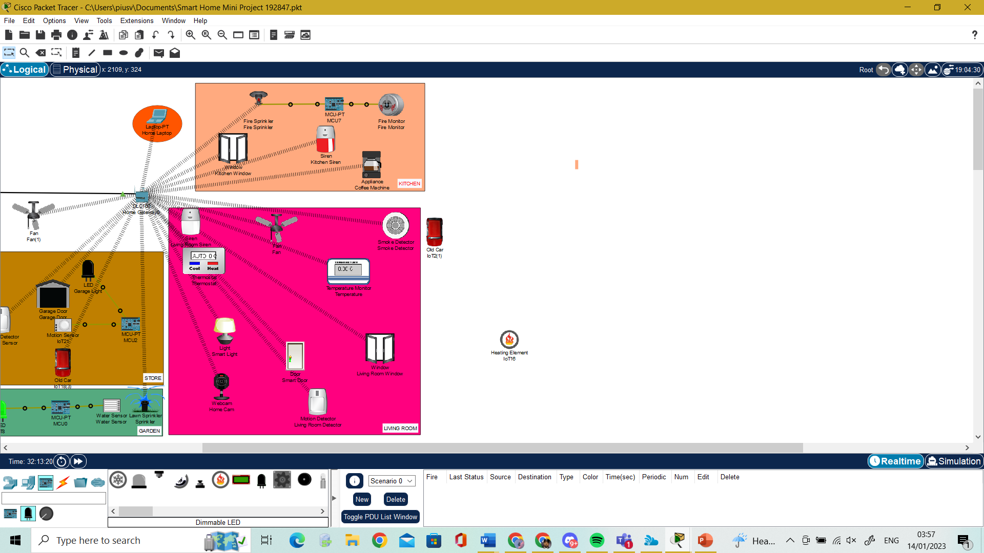

Figure 3.8 Fire Detection Python Code

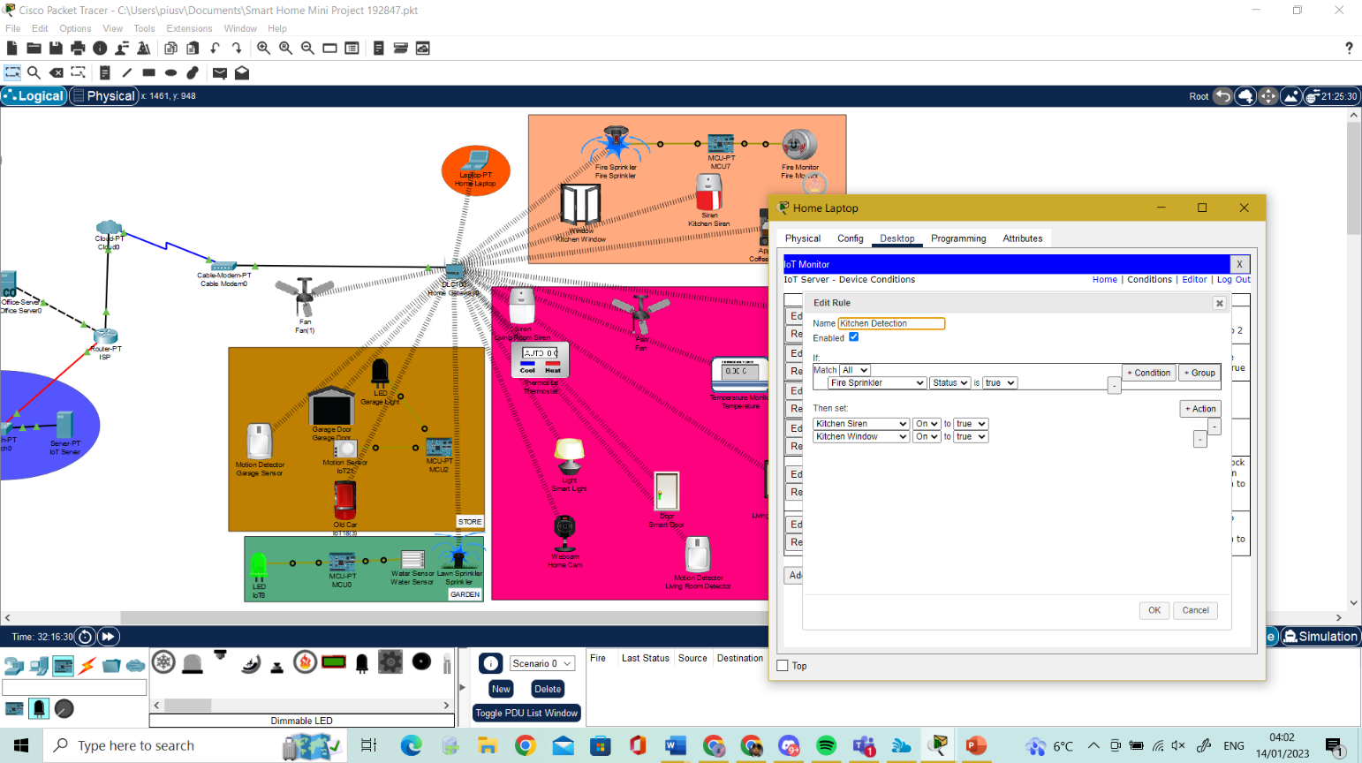

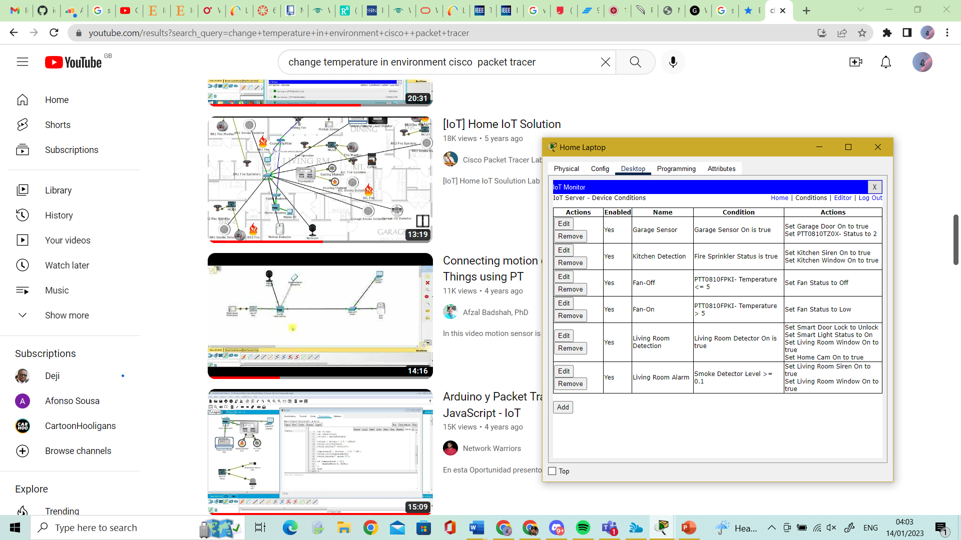

Figure 3.9 Fire Detection Configuration

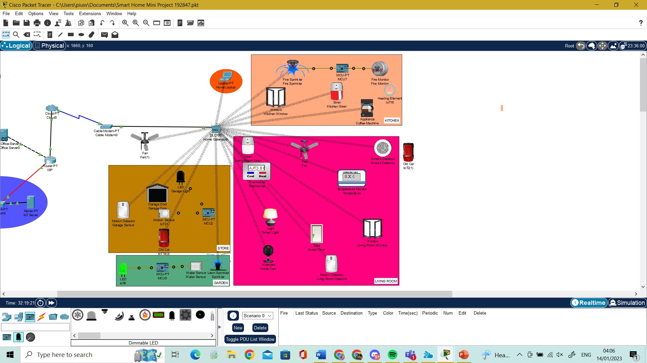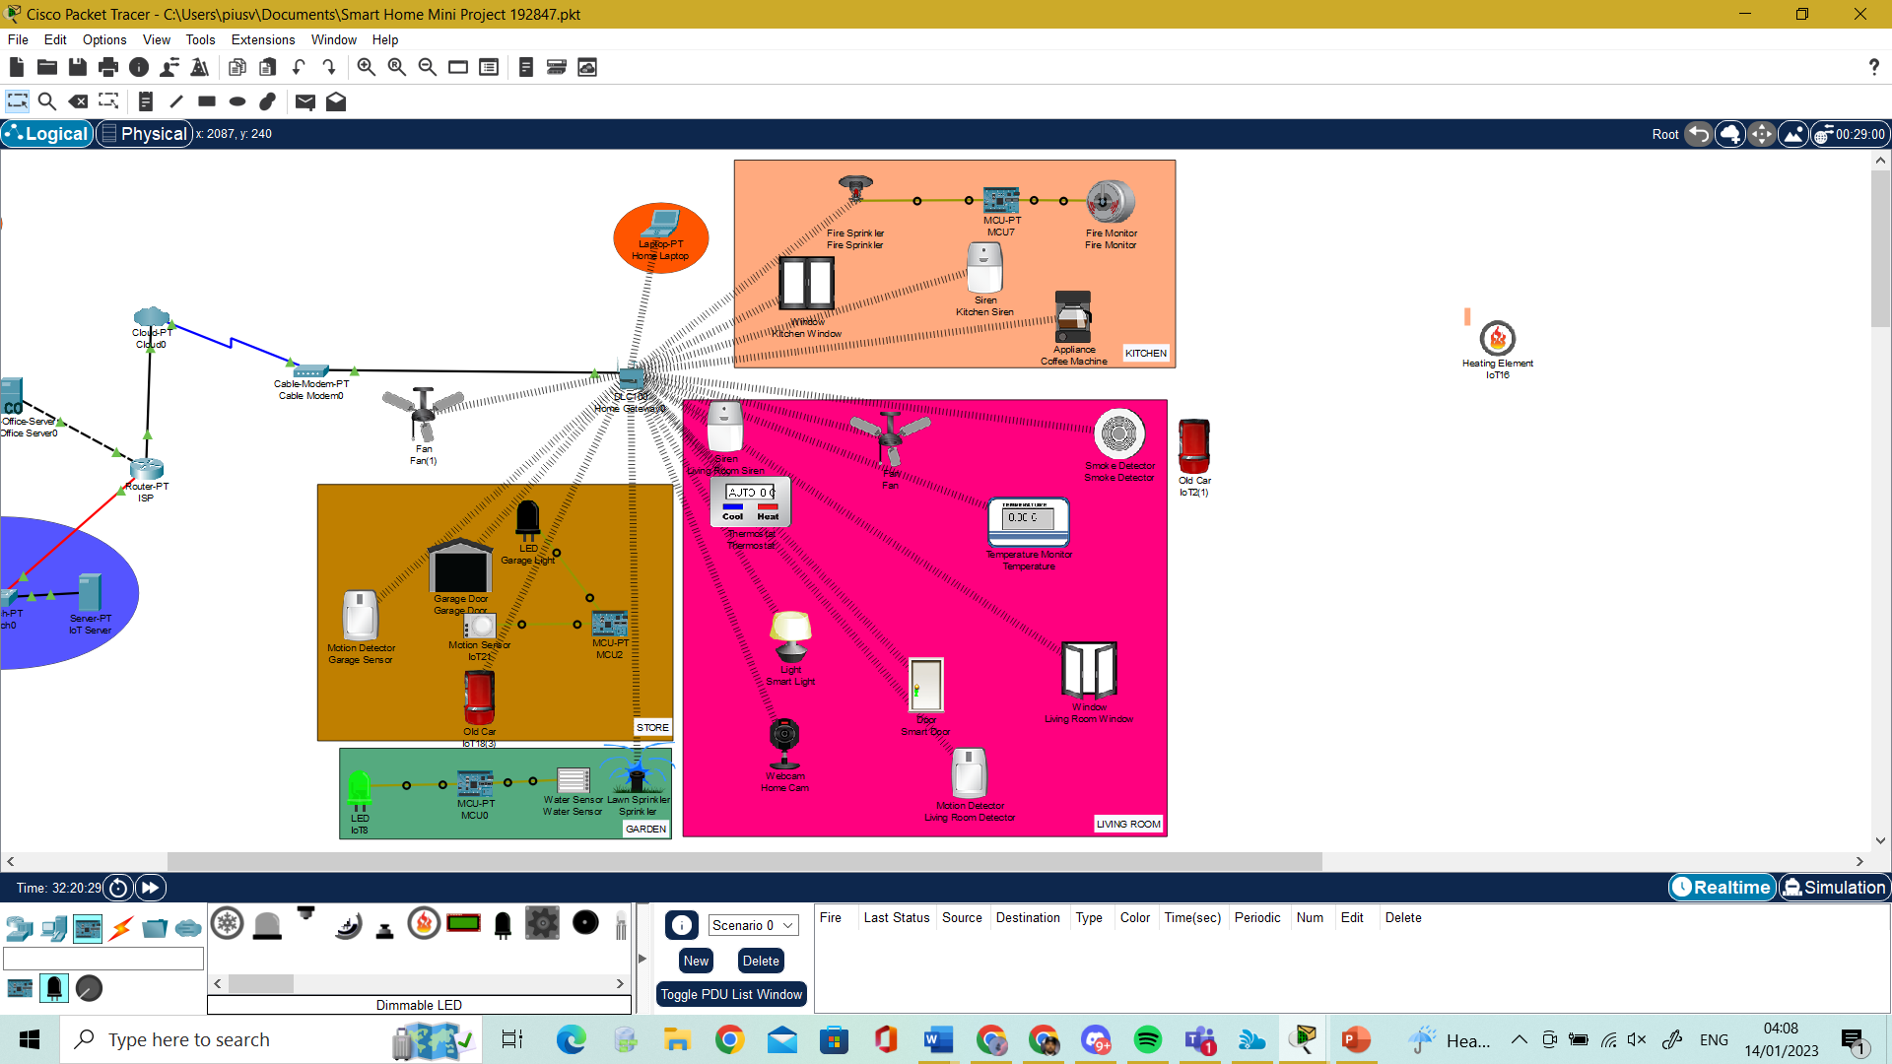

Figure 3.9 Fire Detection with Heating Element

## Conclusion

This report has showcased my mini project an IOT smart home system designed in Cisco Packet Tracer and explanation into IOT. The report has focused on a broader understanding of IOT and its history and current trends of IOT in the environment.

## Bibliography

Gillis, A.S. (2022) “What is IOT (internet of things) and how does it work?”

Elazhary, H. (2019) Internet of Things (IoT), mobile cloud, cloudlet, mobile IoT, IoT cloud, fog, mobile edge, and edge emerging computing paradigms: Disambiguation and research directions, Internet of things (IOT)

Tao Liu and Dongxin Lu, "The application and development of IOT," (2012)

Anon (2020) IoT. [Online]. Basel: MDPI.

Kim, T. et al. (2017) Smart City and IoT. Future generation computer systems. [Online] 76159–162.

Liyanage, M. et al. (2020) IoT security: advances in authentication. 1st edition. Madhusanka Liyanage et al. (eds.).

Tamboli, A. (2022) Build your own IoT platform: develop a flexible and scalable internet of things platform. 2nd edition. New York, New York: Apress L. P.

Bombal, D. (2018) Cisco CCENT Packet Tracer Ultimate Labs:  ICND1 Exam Preparation Labs.

Mishra, A. et al. (2022) Design and Implementation of Smart Home Network using Cisco Packet Tracer. ITM web of conferences.